Trip Report for the Cultural Exchange group in the
2014 Wisconsin-Chiba Inc. Delegation

The Cultural Exchange Contingent of the 2014 Wisconsin-Chiba Inc. (WCI) delegation was The Garlic Mustard Pickers. This is a traditional Celtic music group with its roots in community service work.

The band was formed in 2003, and all of its members have been long-term residents of the Milwaukee area. The band’s members had already worked together for several years in a local program that controls invasive plants (like “garlic mustard”) when they discovered their mutual interest in Celtic music and decided to form the band.

The band is made up of eight musicians, seven of whom were able to travel with the WCI delegation. All of these musicians had traveled to countries outside of the USA, but only one of the musicians had previously been to Japan.

All of the musicians have interests in other cultures, which is one reason why the band has been a participant in Milwaukee’s “Holiday Folk Fair” for nearly a decade. (The Holiday Folk Fair is sponsored by Milwaukee’s International Institute, which is a key participant in the WCI program.) It is probably because of the band’s regular support of Holiday Folk Fair that the band was asked to be the Cultural Exchange component of the 2014 WCI delegation.

Since all seven of the musicians were seasoned travelers, they all had some expectation of what the trip to Japan might be like. However, as is revealed in this Trip Report, the actual experiences of the musicians went far beyond anything that they might have expected. Even the musician who had previously been to Japan had made those trips for business, not as any sort of tour or vacation, and he found the trip (as arranged by the Chiba-Wis- consin Association) to provide a far more detailed picture of Japan and its culture than anything he had been able to glean from “off-hours” walks through Kobe and Osaka.

To provide a view of how much each of the band’s musicians gained from doing this Cul- tural Exchange visit, each musician had a part in writing up this report. Two musicians’ names do not appear as authors, but those two musicians are married to other musicians who appear in this report as authors.

A short conclusion is presented at the end of this report.

6 November 2014 (Tuesday):
Don Lawson

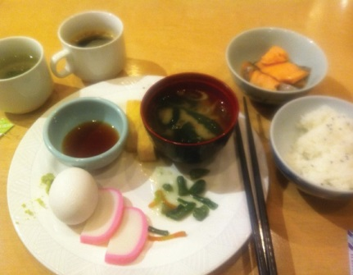
The Mercure Narita hotel has a terrific breakfast buffet, including grilled fish and some exceptionally good miso soup. (Don has made a number of business trips to Japan, and his opinion is that the breakfast buffet at the Mercure is better than anything he’s encountered on his various stays in Kobe and Osaka.)

The Science and Technology contact person decided to stay overnight at the ho- tel, since his affiliation is with an institution located quite a distance from Narita. It was nice to have his company during breakfast. He taught Mark how he eats natto (with rice and nori, so it doesn’t stick), and talked about how his parents would make natto when he was a boy wrapping the soybeans in leaves and allowing it to ferment. He also said that, compared to what we were having for breakfast that morning, what he had as a boy wasn’t very good.

After breakfast, we had a little bit of free time, so the band decided to take a short walk near the hotel. The weather was beautiful, in the low 60s and sunny... far nicer than the weather we left in Wisconsin! We walked a small loop, and got a feel for where we were. It was still relatively early in the morrning, so we were walking past people going to work, and students on their way to school. We all
felt fortunate to be experiencing what felt more like “everyday Japan”, and not just tourist destinations.

After the other two delegation groups left the hotel, our group’s host fami- lies drove us over a studio that specializes in traditional Japanese dance. The
studio is run by Tsubaki Wakako, who is the grandmother of the Tsubaki family. Her daughter Rei explained (through an interpreter) that the wigs and outfits were originally worn by men who were playing the parts of women characters (in plays etc.). A very elaborate wig with flowers would be used to portray a prin- cess. We saw around four or five wigs. The last wig that Rei brought out was for a male character, and it had hair that was parted in the front, instead of being swept from the front to the back.

The wigs are all custom-made, with a shell that is custom-fit to the person’s head. The hairs (which are from women) are then attached to the shell.

It was explained that some of the costumes used in Noh and Kubaki were so elabo- rate that they weighed as much as 16 kg, which works out to be around 34 lbs.

Bobbie got to wear a kimono with very elaborate embroidery. Red background, with circular patterns of vivid greed, blue, and yellow. There were cranes embroi- dered onto the fabric, along with “medallions” of gold-colored thread.

All band members were then encouraged to try on kimonos. The men’s garments had regular geometric patterns and simple belts. The women’s kimonos generally had much more elaborate patterns and colors, and used very lavish broad belts.
The most florid example of an elaborate kimono was the garment offered to Bobbie.

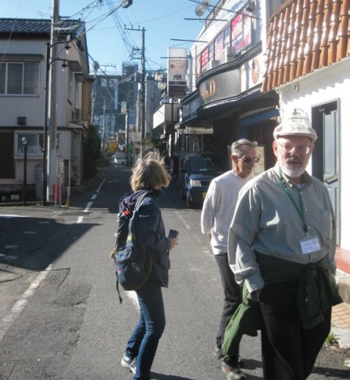
Breakfast at the Mercure

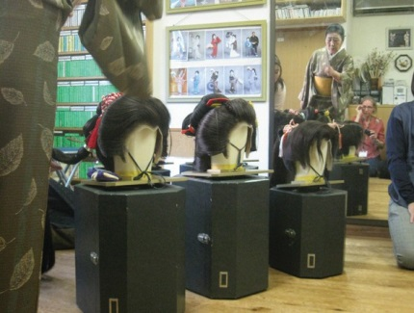
A morning walk in Narita

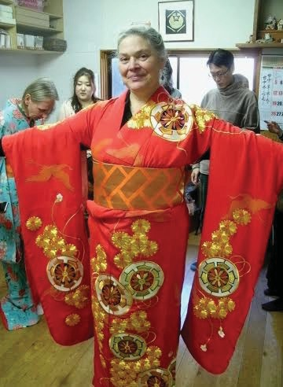
Dance wigs

Bobbie in her kimono

After trying on the clothing, we were asked to fold the kimonos again. This was a bit of a trick, but it helped to realize that the folds needed to go along the seams of the garment. As I folded my garment, I realized that much of the styling came from how the garment was made from large rectangular blocks of fabric. It felt very much like how we were taught to fold a flag back home.

After visiting the dance studio, we went to a Japanese-style restaurant for lunch. This was the only establishment that we visited on our Chiba visit (other than the Tea Ceremony room) where the seating was cushions directly on the floor. As had been the case at the dance studio, the Japanese women were able to sit on the floor with their feet extending straight out behind them. However, the band members could barely manage to sit cross-legged on the floor. Our food at lunch was very good, with a good-quality miso soup, tempura, rice, etc. Mark texted a photo of his lunch to his family, and his daughter asked, “is all food in Japan so beautiful?”

After lunch, we went to a large Buddhist temple complex in Narita (the Narita- san Shinshoji Temple), and we picked up a volunteer tour guide who did a
very good job of explaining things as we walked around the grounds. (It would not be surprising to find out that Aoki had made arrangements for the tour guide to be available for us.) Our guide was a gentleman who speaks very good English, and to supplement his commentary he was able to give us brochures that were written in both Japanese and English.

The outermost temple gate had a Chinese/Japanese zodiac set of sculptures. This outer gate was supposed to be a site that would spiritually cleanse visitors from impure thoughts and keep evil out of the compound.

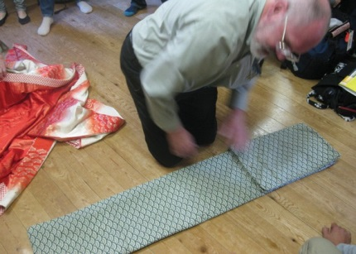
Don folding a kimono

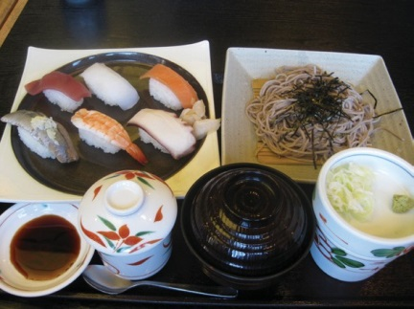
Mark’s lunch.

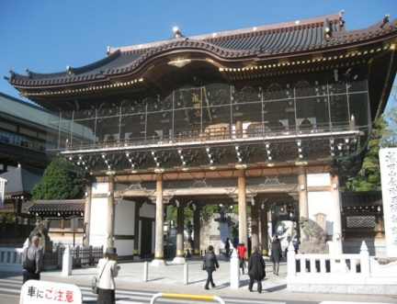
The main gate at Narita-san Shinshoi Temple

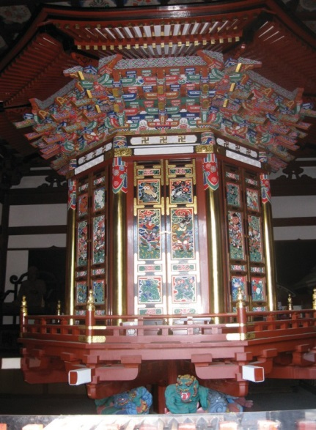
After going through the outer gate, we came the place where we could wash our hands with bamboo scoops. (The ritual is to first wash one hand, then wash the other, then use one hand as a cup so you can wash your mouth (and swallow the water, not spit it out), then catch one more cup of water and let it run down the handle of the cup.. After this, we went though a second gate (with two “devil” sculptures, one devil with an open mouth, and the other with a closed mouth. The large rattan at this second gate is made of steel, and was donated by fish- ermen of the Tokyo fish market. This “rattan lamp” weighs 800 kg - i.e., approximately one ton in USA measure- ments. (The fact that this rattan was donated by people as far away as Tokyo indicates that this temple complex has a noteworthy prominence in Japan.)

After the second gate, we came to an incense fire, where we could wave smoke over ourselves and breathe in some of the smoke as a symbol of divine wisdom.

There is quite a collection of different shrines and buildings in the site. A rotating holder of Buddhist scripture hadn’t been physically rotated in quite a while, be- cause the hinge assembly was starting to wear out. But, this rotating library was several centuries old, .and so it’s understandable that the hinge has aged. One of the pagoda towers dated from the early 1700’s and has a suspension system that allows the upper section to swing as a pendulum (relative to the first story’s base) when earthquakes strike.

The temple complex is devoted to Fudo Myo-o, the fire god who is an incarnation of the Cosmic Buddha. Three buildings have successively been used as the

The rotating Buddhist scripture library

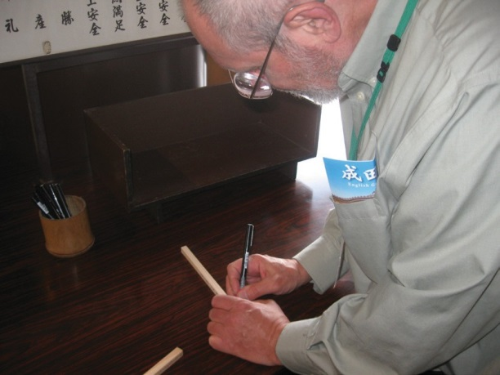
Main Hall for worship ceremonies. Each of the earlier buildings was built on a primary site, and after a century or so of usage was moved to nearby location so that a new (larger) Main Hall could be built. The oldest building had been built in the 1700s, the next most recent in 1855, and was moved in 2009. The current hall was built around 2010, and was finished in 2011.

The day that we were at the complex was one of the four times per year that there is a “Goma” ceremony of burning sticks with mes- sages on them. Our band wrote onto two sticks. One stick was for the group (wishing for peace and understanding), and the other was used by Don to express thanks for health and other blessings. The sticks were later collected to fuel a fire on an altar inside the main hall. At one point in the ceremony, the worshippers in the audience offered bags to the monks, who waved the bags into the smoke to bless them. Bobbie offered up her purse for this smoking ritual.

After the ceremony, we went down towards the main gate. We passed a pond with a turtle-shaped rock, with turtles in the pond. Turtles are a symbol of a long life. It was 33 steps from the main complex (the plaza that includes the rotating library and the main hall) to the pond, three steps from the pond to the next staircase, and 17 steps down to the lower plaza (with the incense fire). The sum is 53 steps, which agrees with an old story about a monk’s dream of a stairway going upwards to enlightenment (and having 53 steps).

After visiting the temple, we went to the house of the Tsubaki fam- ily, where we were treated to a potluck meal provided by all the Cultural Exchange host families. We then enjoyed an exhibition of traditional dancing.

The class of dancers included Yuga, who is the teenage son of our hosts, plus around 4 or 5 girls. All of the dancers appeared to be middle school students.

The first dance was “Tears in Okanawa,” danced by one of the girls. Then Yuga son did a dance which showed great artistry. Both of the solo dances communicated a considerable degree of feeling. After this, three girls danced together.

Finally, Wakako (the woman who runs the dance studio) got the WCI delegates (and many of their hosts) arranged into a circle, handled us all plastic fans, and taught us a simple dance.
Writng on a prayer stick

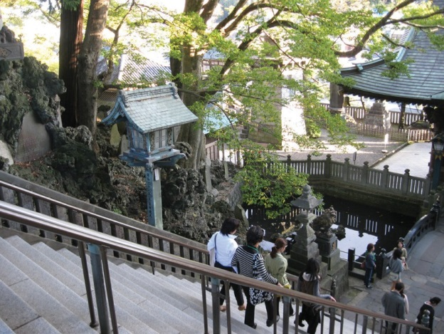
The steps and turtle pond

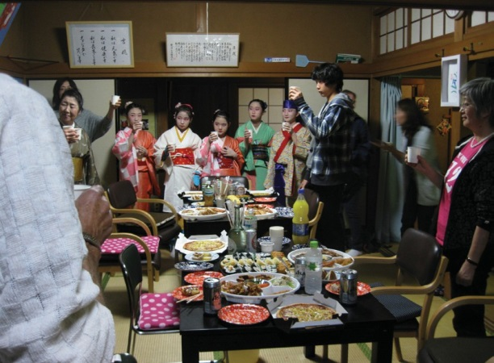
The gathering at the Tsubaki house

The dancers are arranged in a large circle. (It was convenient that the Tsubaki family has a large “living room,” because we were quite a crowd.

The first part of the dance was tapping of the fan: followed by three rotations of the fan. The lift the fan, wave it into the circle, out of the circle, out of the circle, into the circle, then hold the fan down for three steps and three sweeping motions.

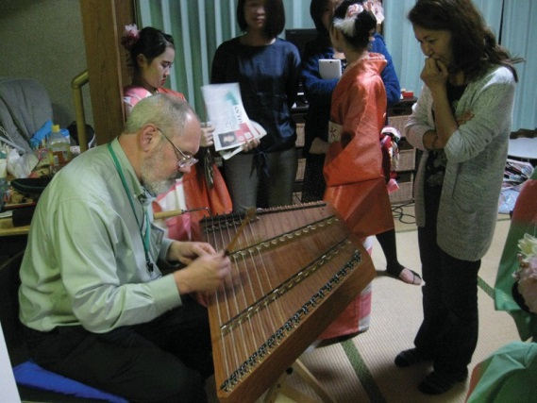
After the dancing, Don, Dave, Mark, and Bobbie pulled out their instru- ments and ran through some tunes, but the quality of our performance was badly affected by our fatigue, and the rosin on Bobbie’s bow (be- ing suitable for a dry Wisconsin winter) was misbehaving in the warm humid air of Chiba. However, this chance opportunity to run through tunes in our performance line-up was extremely useful, since we were going to be doing our first performance early the next day.

Note the future Cultural Exchange Groups: If the group is a musical group like ours, it would be extremely helpful for host families to provide an opportunity and location to do a “first evening in Wisconsin” or “first
evening in Japan” run-through without feeling like the musicians are on display. Also, it probably would have been helpful for our band to have received a suggestion that we’d have an opportunity to do a run-through of some tunes. This impromptu “potluck evening” performance was an idea brought up by Don and Mark, but the idea was hatched after we had arrived at the Tsubaki household. The drawback of this was that Pam and Debbie did not have their instruments, nor their music books).

At the end of the dancing and music, it was time for everybody to go their respective Host Family houses. The four guys in the band were staying at the Tsubaki house. Dave and Joe were in a bedroom, and Mark and Don were given futons in what would normally be the dining room.

A “goodbye kiss” between Don and Bobbie drew titters of laughter from some of the moms of the dancers. This sort of PDA (“public display of affection”) is clearly on the boundary between acceptable and unacceptable be- havior in Japanese culture. But, it must be barely on the acceptable side of things, because later in our tour the other married couples were doing similar “goodbye kiss” routines in the lobby of City Hall at the end off each day, and none of our hosts made any comment at all.

5 November 2014 (Wednesday):
Debbie Wilhelm

Magokoro ‘Be Ambitious’ Social Welfare Corporation, Narita Kokusai High School

The day started out with the culture group having breakfast with their re- spective host families and then meeting with instruments at the Narita City Hall. At the City Hall I was amazed by the wall of small TV’s that were showing programs from around the world. Opposite the wall of TV’s was a mural and a display of what appeared to be a shogun warrior. This statue was very similar to ones we saw later in the week at the Narita festival atop parade wagons. After loading our instruments onto the van that was our transportation for the day we headed out to visit the ‘Be Ambitious’ Social Welfare Corporation. ‘Be Ambitious’ is a corporation who teaches mentally challenged students from 16 to 19 years old skills so they can take their place in the workforce and earn money to make them more independent.

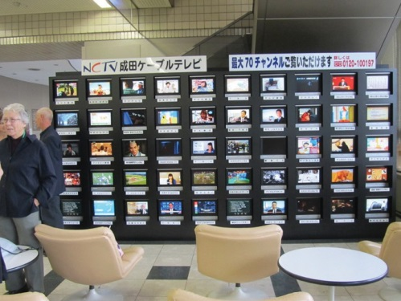
The TVs in Narita City Hall

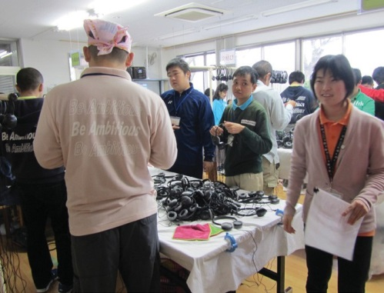
Upon arriving at the modern two story building that is the home for the corporation we were met at the door by the staff. We removed our shoes and put on slippers that were provided. We were escorted to the second floor where in a large room with audience chairs set up we stored our instru-
ments for the time being. From here we left on a tour of the facility. We were introduced to a 15 year old young lady named Shiho Kamagata. Shiho was a student of the corporation and had been awarded the title ‘2014 Ambassador’ for the program. Shiho was very shy at first and very intense when she gave her welcome speech but we all loved her on sight. She had a wonderful smile. During our tour we saw a number of rooms where differ- ent skills were being taught. The first room had a group of youths untan- gling headsets that were given to them from various airlines. They were to

separate each one from the pile and then hang them over what appeared to be a clothes rack. The headsets were sanitized, repackaged and returned to the airlines for use on future flights. In another room silverware was being

Our tour guide, Shiho Kanagata

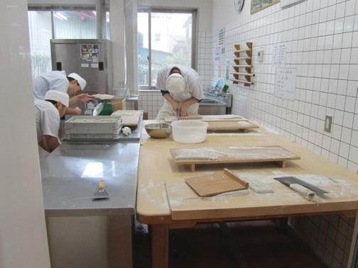
wrapped into napkins. This project was also for use on airline flights. Anna Airlines was one of the airlines sponsoring these activities.

During the tour we were shown the campus lunch room, met the staff who does the cooking for the students and learned about the healthy lunches that were served Our next stop was a room where a soba noodle making program going on. We were shown how the buck wheat was ground into flour, water added to make the dough, rolled out very thin with a wooden roller and then placed on a wooden slat and cut into the very thin noodles that become the soba noodle. The young men who were cutting the noodles were very focused on their tasks. They had a wooden board that sat atop the dough and they used that to guide them for cutting the noodles into the very thin strips. We learned that the students ate the noodles at

Preparing soba noodles

lunch and also sold them for lunches that were served to the public in the small restaurant that was part of the corporation campus. After this interesting experience we were taken past the bakery where, thru a large win- dow, we could see those students who were interested in learning to bake and cook making cookies and cakes. These items were sold at the bakery that was on campus and open to the public. During our walk thru the building we saw some artwork and a small courtyard with metal figurines of children and animals. It was a very cheerful setting.

After our tour we met with the director in her staff room where we were served tea and listened to the director explain the philosophy behind the founding of the corporation and its goals for the men- tally challenged. The director told us, thru a translater, that she had had a stroke a few years ago, in fact she was still paralyzed in her right arm, and how she knew some of the challenges of being handi- capped. From the staff room we headed upstairs to set up and tune our instruments. We performed a 40 minute program for the 60 students and staff. We could see the students were having a good time as they were moving in their chairs in time to the music and clapped loudly. They were especially interested in the kilts the guys were wearing that day. It was noon when the performance ended and we were escorted from the gig room to be treated to lunch at the campus restaurant. The short walk to the restaurant was lovely with pretty flower garden plots along the walk way. At the restaurant we were served the soba noodles that were made on the grounds along with tempura vegetables and dipping sauces. I learned the proper way to eat the noodles – putting chopped onion and wasabi into the sauce and then picking up small amounts of noodles with my chop- sticks and dipping them into the sauce. It was delicious and very special knowing the noodles had been made fresh by the students. After lunch we were all given a gift envelope which contained a booklet on the school and a kimono coaster which turned out to be made by Shiho. As a craft project Shiho takes pieces of old ki- mono’s and sews them into these coaters. Knowing these were had made by Shiho made them especially precious to all of us. Tho we

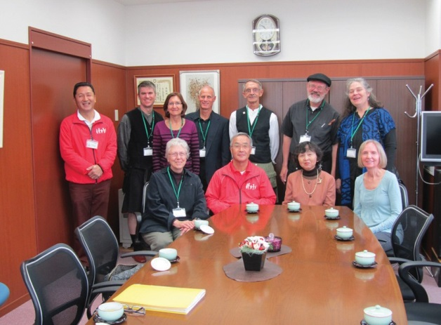
The direcors of Be Ambitious and the Garlic Mustard Pickers

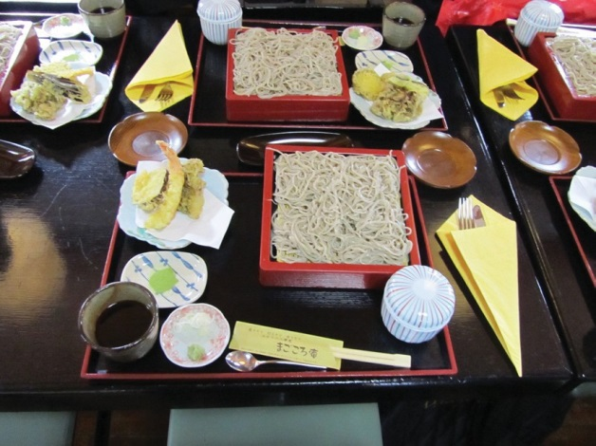
Our lunch at Be Ambitious

hated to leave, we exchanged our slippers for our street shoes, collected our instruments and headed to the bus. As we loaded up the bus the students and staff lined up outside to wave good bye to us as we boarded and the bus pulled out. Everyone was so friendly, the tour here made a big impression on all of our group.

After leaving Magokoro, the Garlic Mustard Pickers tour bus headed to Narita Kokusai High School. The principal, vice prin- cipal and 2 of the students who could speak English were there to greet us. After exchanging our shoes for slippers, we were lead to the principal’s office where we were treated to tea and learned about the school and its international program. Our next stop was to
a classroom to learn about calligraphy. The instructor was a well known Japanese calligrapher. Translation by Aoki, the instruc- tor gave us a lecture on the history of calligraphy, its many differ- ent styles and showed us 6 different styles for writing the character ‘wa’. We were given paper, brushes and ink so we could practice drawing the characters ourselves. Our best example was given to the instructor to be framed Japanese style and the school stamp ap-

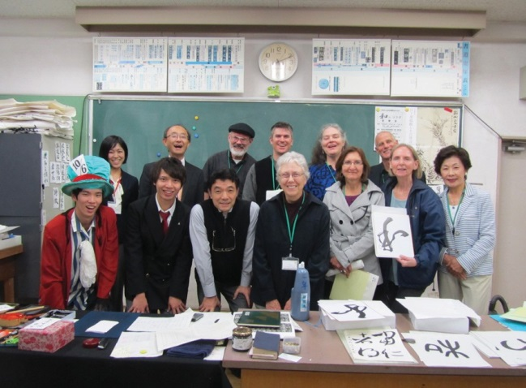
Our caligraphy lesson

plied. From here we collected our instruments and headed to the auditorium to perform. The students were already assembled and sitting in the risers. They applauded as we walked in and took seats in the first row. The program was begun with an announcement by two of the students (one in a mad hatter’s hat). Students from the judo club came on stage to perform. We learned they rank as #1. The next group to perform was the high school band. Their first piece was very lively and energetic. There was a gymnastics team that did a routine
to the music that was being played. For the final piece, the band performers put on masks and danced at their

stands as they performed. It was a fantastic performance and a hard one for our band to follow. However, even though we didn’t put on masks and dance at our stands, the students enjoyed our music. After our performance the students came down to the floor to talk with us and have group pictures taken. Since time was running out, we packed up the instruments, went up two flights of stairs to collect our calligraphy pictures and then load and board the bus. The staff escorted us to the bus and waved goodbye as the bus left the parking lot on its way back to the Narita City Hall.

It was a full day of touring and performing but I was extremely impressed by how friendly everyone was and how well we were treated. There were times I felt like a diplomatic dignitary with the special attentions we were ex- tended, the refreshments we were greeted with at both visits and the lovely gifts we were given. The atmosphere of the places we toured was impressive. The staff at both were devoted to their students and it showed in the faces of the students and the activities we saw.

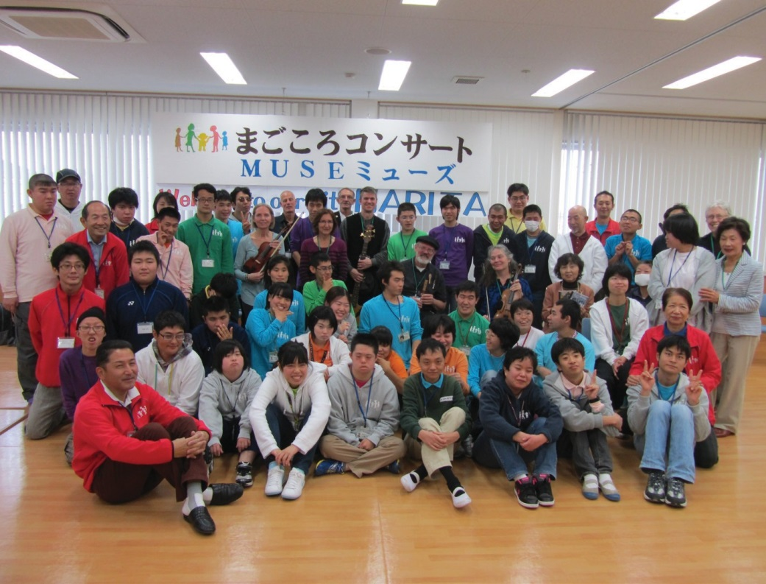

A picture with our audience at Be Ambitious

6 November 2014 (Thursday):
Pam Uhrig

It was a bit drizzly and overcast in the morning as we met at the Narita City Hall at 8:30. Everyone was eager to begin what was to be a very busy day.

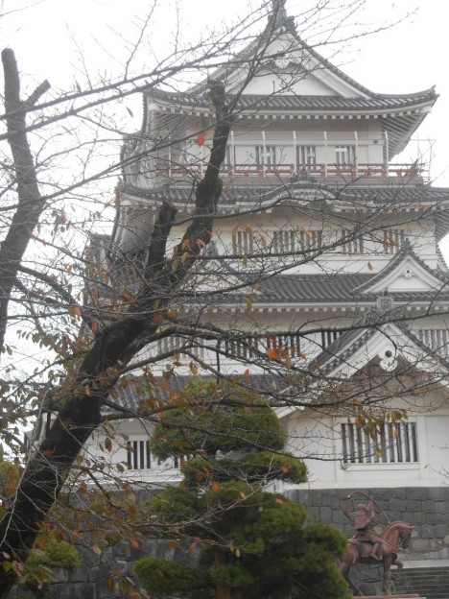
Our driver took us to the Chiba Folk Museum, which is located on a hilltop in downtown Chiba, where we had an hour to explore the museum and the surrounding park.

A picturesque castle on a hilltop in downtown Chiba, presently the home of the Chiba City Folk Museum. The present castle is a reconstruction designed to house the museum in 1967, built on the site where Chiba’s namesake Chiba Clan once ruled from their own fortification, Inohana Castle.

The Chiba were an eastern branch family of the Taira Clan that sided with Minamoto Yoritomo when he rose up to become the first shogun of Ja- pan. They remained important allies of the Kamakura Shogunate (12th ~
14th c.) then declined in influence in the following Muromachi and Sengoku periods (together 14th ~ 16th c.). http://www.ccb.or.jp/e/_sightseeing/2262

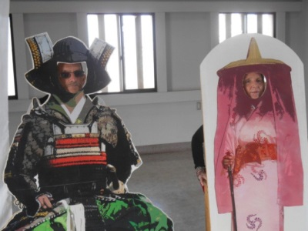
The museum was not busy and it was suggested to us that we start on the 5th floor and work our way down. There was a nice view of the city from the top floor even though it was a foggy day. We had fun taking photos of each other putting our faces in the life size shogun cut outs. The amour exhibit was quite impressive and we commented about how ancient their history is compared to the U.S.

We especially enjoyed the park area surrounding the museum where we had a lovely view of the building and could imagine how beautiful it must be in the spring with the cherry blossoms in bloom.

Back in the van, our driver took us to the Chiba Prefectural Government Office in Chiba. We were escorted to a room where we were seated to await the arrival of Governor Eiji Suzuki(Suzuki Eiji). As we sat in the front row of the assembly, we could feel the anticipation of his arrival as the press was ready with their cameras and officials were busily making sure that everything was in order. Suddenly he
arrived practically running up to the podium, all smiles and full of energy. It was a very warm and lively welcome and the interpreter introduced each of us by name. Sharon spoke of the history of the Chiba Wisconsin International connection and how much each country has grown by forming friendships with individuals and families on a very personal level. Sharon presented a gift to the governor and he likewise presented her with a lovely Japanese art print.

At the end of the session we were each given a gift bag consisting of a tour guide, maps, a pen, and an adorable stuffed Chiba-kun toy.

At noon we ate in the dining hall and were served a delicious hot lunch. One of our hostesses made an especially beautiful treat. We learned that is was a local tradition. “Chiba’s most representative traditional foods is futomaki-matsuri-zushi,

Playing with cutouts

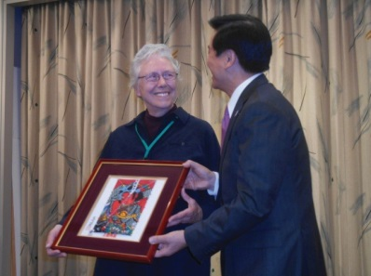
Sharon Durtka and Gov.
Suzuki Eiji

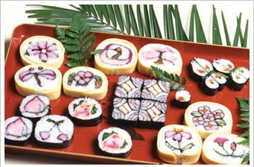
Futomaki-matsuri-zushi

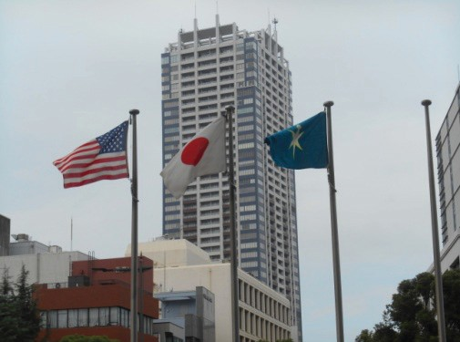
or “thick-rolled festival sushi”. These unique and colorful sushi rolls have been made for special occasions and festivals since times of old, and are an- other form of traditional culture that we pass down through the ages.”

As we left the government building we saw that they were flying the Ameri- can flag alongside their own in honor of our visit. It left us feeling quite awed and humbled to be given such a warm and generous welcome by the gover- nor and his staff.

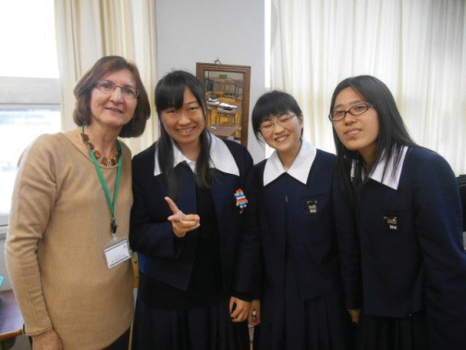
After a quick but enjoyable lunch, we were back on the van for a scenic drive to Chosie High School in Mobara city. The one hour drive took us on roads through the country where we
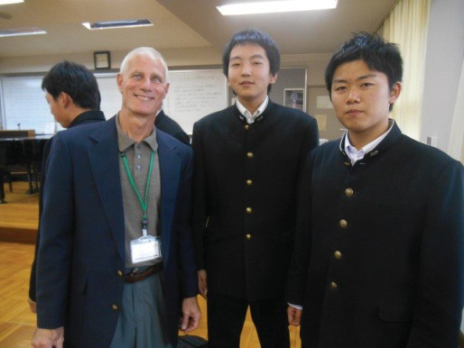
got a glimpse of various crops growing in the fields and smaller villages. When we arrived at the high school and entered the lobby, there were rows of empty lockers where we put our shoes and then put on the slippers that were provided for us. We followed our guides to a classroom where English is taught and the students were sitting at tables in groups of 2 to 4. The 7 members of the band sat in a row at the head of the class and each of us was given a card with a number and a phrase. The instructor asked a question about Wisconsin and the band member with the right answer was sent to the table with the corresponding number. It was a fun way to introduce the next activity. Each of the band members was then interviewed by the students
at his/her table. The girls at my table were quiet and shy and it took a lot of courage for them to speak English and interpret how my answer should be written down. At the end of the interviews, a spokesperson from each table gave a short report on what they had learned about each of us. The staff and students were all so friendly and we enjoyed being able to share our stories with them while helping them with their English in a very fun and relaxed activity.

Our band then performed a piece called Slibh Russell. From there we went to a conference room and enjoyed tea with the principal. He presented each of us a towel with the school’s name and logo which is “Spirit, Nobility, Wisdom”. As we left the school, many students and staff waved and sent us on our way.

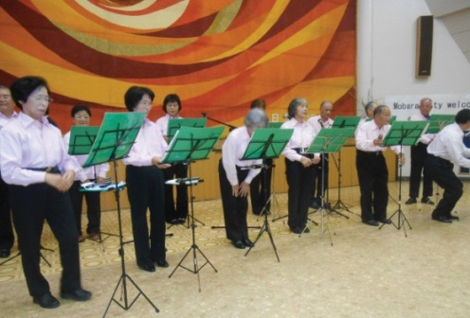
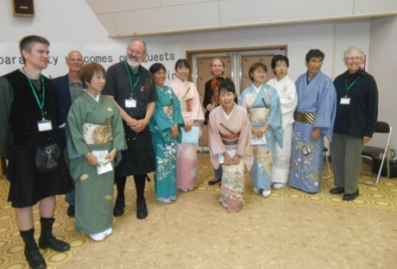
We arrived at the Mobara City Center and waited in the lobby for our next performance. After being seated in the auditorium, the show started with speeches by the Chairperson of Mobara. Following that was a performance by Nezumi, woman in colorful kimonos playing Japanese style flutes made of bamboo, and a man playing a drum. The music was beautiful and the group performed several numbers that also included wooden blocks, bells and a Japanese guitar or Shamisen, played with a Bachi(looks like an ice scraper). The next group of men and women performed with harmonicas. There were harmonicas in all sizes and the music was a mixture of familiar tunes and traditional music. The Garlic Mustard Pickers then performed music from our first set, with introductions from Sharon and Ioki. We pre- sented them with our CD and they presented each of us with a key chain.

Back on the bus Aoki handed out cracker/fish snacks for the drive back to Narita city hall where we each met our host families at 6 pm. After a very busy day, we were all pleasantly exhausted from such stimulating and en- riching experiences.

7 November 2014 (Friday):
Bobbie Groth

Another loooonnnngggg day!

We met at Narita City Hall at 8:15. It is so nice to get together again after our nights at our separate host fami- lies—everyone is expectant and hopeful for the day, and we get a chance to once again practice our Japanese greetings and bows. Our host families gather around us and see us off for the day—it is a wonderful feeling to be surrounded by their support and friendship!

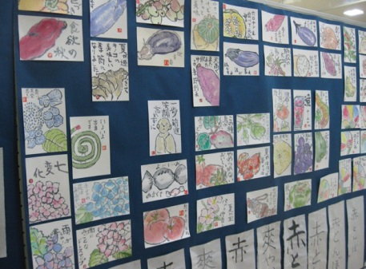
We left for Akasaka Community Center where we saw a wonderful display of animal and flower and vegetable drawings done by the seniors who meet there.

We knelt on pillows and learned the history of the formal tea ceremony from our teacher beautifully outfitted in a traditional Kimono. Then she took us to an inner room which was modeled after the traditional part of a house, with grass mat flooring, a fire recessed into the floor on which to boil the tea water, and cushions surrounding the perimeter of the room. We each knelt on a cush- ion while she explained the tea ceremony to us.

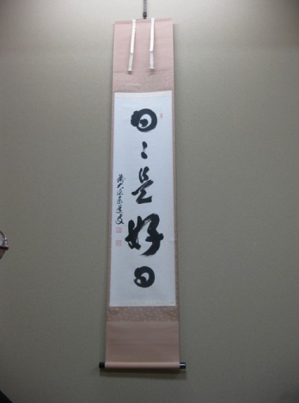
It is a great honor to both give and receive the tea in the traditional ceremony. When you enter the tea room, you enter in peace, and each day a new inspirational scroll is hung on the wall to set the tone for that day. Ours had characters that meant, “A new day, and happy day, the best day, a peaceful day” (this is a popular saying, and I did see it in English at a souvenir shop when we went to Tokyo the following Sunday). When you enter the tea room to participate in the ceremony, you are to leave your cares and the violence of the world behind. Our teacher explained to us that the reason the entrance door is so short is so that the warrior will have to bend down—everyone must assume humility when they come into the tea room, strong and weak, powerful and not so powerful alike. The warriors cannot bring their weapons in the tea room. It is a place of refreshment, honor, and peace.

The mistress of the tea ceremony dips the hot water from the kettle into the tea bowl. She says some ritual words to do this. Then she puts in the Mitchi powder, and whisks it in a very particular way so that the tea powder mixes with the water evenly, and a great froth of bubbles is created. Then the bowl is placed with it’s special painted image away from the tea drinker. The tea drinker picks it up and offers it up while bowing their head. Then, the tea bowl is turned in the hands until the icon faces the other way, and cradled in the palms, the recipi- ent of the tea honor begins to sip their tea, relax, and enjoy the honor and the peace of this ancient tradition.

After we were given our first bowl of tea, we were then taught to make the tea ourselves. I think Dave did the best job with the least amount of coaching! We all tried our hand at the proper amount of Mitchi powder with the special spoon, and manipulating the rattan whisk to get the profusion of bubbles that are sought. We

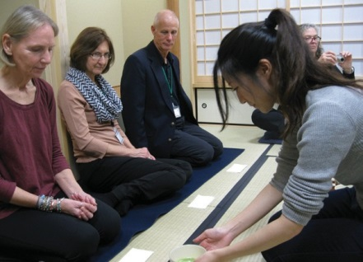
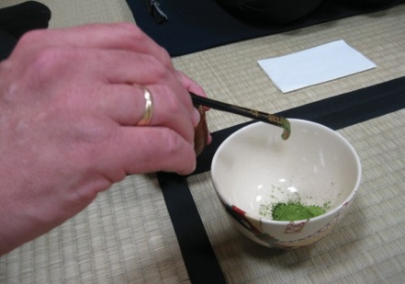
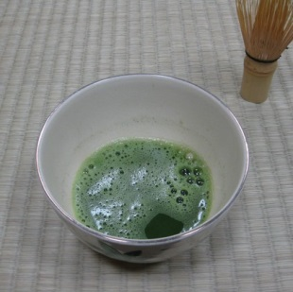
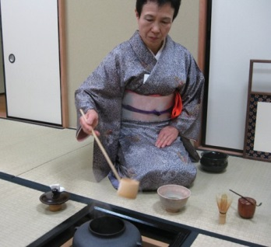
Our hostess Receiving our tea Adding matcha to the cup A frothy cup of matcha

liked it so much, we did it a second time! Don and I were taken with this, and made sure we had visited a local tea shop in Narita and purchased the requisite supplies to do our own tea ceremony at home, before we left.

After our appreciative thanks, we left for Kozu-no-mori Junior high school where we received a fourth bowl of tea and many generous gifts as the principal talked to us about this brand new absolutely gorgeous school. Of course, this once again involved removing our shoes and wearing slippers to come in, as has been true of all the schools we visited. Our big American feet do not fit well into the slippers, so managing the stairs was a particu- lar challenge—we were often stopping for someone to retrieve a slipper that got away from them. The three men wearing kilts were particular gorgeous in their slippers!

We had a 30 minutes performance which we now have a standard format for: Aoki-san reads the introduction in Japanese to the students. At some point she has Mark explain the men’s kilts and each of us talk about our instrument. We generally only have time for about 5 pieces, including a song, and the twenty minutes of playing is up!

We get vast amounts of applause from these gracious and well-disciplined children. They are so refreshing in their willing and enthusiastic engagement with their school programs—I am utterly charmed by the schools and wish all children in America could attend such wonderful schools.

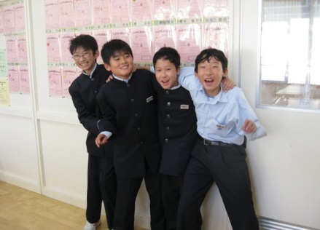
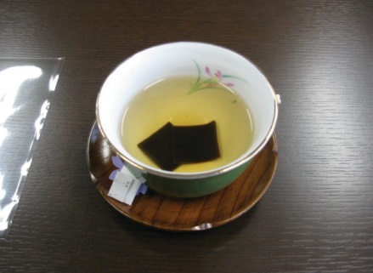
After the concert Don and I were taken by Kenji, a young teacher from Cameroon, to be our guide and inter- preter so that we could eat school lunch with
a classroom of children. He explained that this was like a “home room”. All the children eat lunch in the classrooms. They serve, eat together, then clean up. On this day they had fish, rice, miso soup, and sweet potato. Af- ter lunch they were going to clean the whole school. They do not waste their food, and can

have seconds if they desire. They were funny and curious about how we knew how to eat with
Students at lunch
Seaweed tea at Kenzo-no-mori

chopsticks already, and had a lot of questions for us, that Kenji graciously interpreted to us, then interpreted our answers back to them.

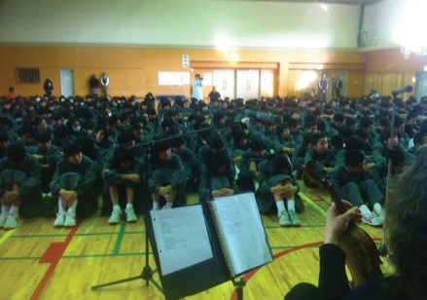
After lunch we went back downstairs for yet another bowl of tea! Then we left for Nishi junior high—very huge and fortress like but also beautiful, and very friendly and homey on the inside.
Another bowl of tea! Our guide was a young American woman named Simone from the South. We performed for twenty minutes. The students sat on the floor and were extremely well disciplined and polite and friendly. They knew the rules and older children helped seat the younger ones. If a student slumped, a gentle reminder from a teacher was kindly done, and respected.

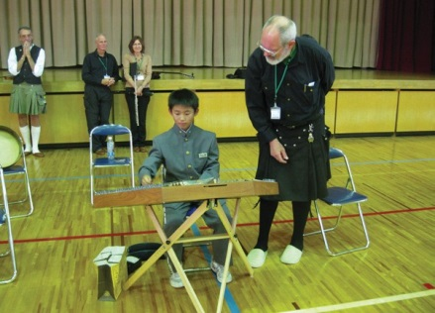
After the performance the children were very interested in trying out the dul- cimer, as were two teachers. They were quite thrilled to get our business card, and to see that we had a website that they could visit on the internet. We went back to the first room we had met in—another bowl of tea! By this time I had tried every restroom (toilet) in the school!! It was worth it—I felt great after all that green tea!

After tea we took a tour of the whole school and the after-school clubs that were in session. The students were very involved in their sports, dancing, music

etc. It was wonderful to hear their voices and their laughter. The very best thing to see was the brass band club, which we went to last. Those students were FANTASTIC!! They were playing a piece for the first time together, and it was amazing—they engage so enthusiastically with their music and seem to really be having fun.

We left the school at 5 pm and went back to City Hall, where our host families picked us up. Every day has been so full of new sights, new ex- periences, wonderful receptions from the people we meet, and more and more feelings of admiration for the Japanese who receive us in such a friend- ly way, and for a culture which is so well suited for the modern world, and
so efficient and welcoming

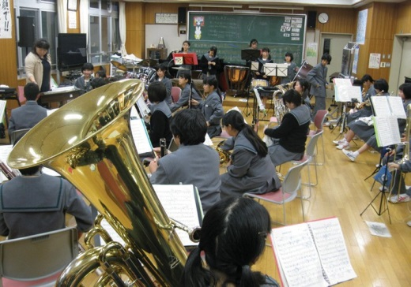
Visiting with the band

Putting on the guest slippers

8 November 2014 (Saturday):
Don Lawson

This day had the “highlight” event of our trip - a folk festival celebrating the 60th anniversary of the incorpora- tion of the City of Narita.

It was explained to us that, in the Japanese culture, a 60th anniversary is a REALLY BIG event, representing time span of five times through the 12-year zodiac cycle.

As we started the day at the Tsubaki household, the guys in the band were told that the weather forecast called for scattered rain. So, we prepared by fitting raincoats and miniature umbrellas into our backpacks. Our suit- cases were packed up and left just inside the front door of the Tsubaki’s house because, even though the Tsubaki van is generously big, it is not big enough for both our instruments and the suitcases. So, we placed our instru- ments and other “gig” gear into the van, leaving the suitcases for Chikara Tsubaki to deliver to the hotel later in the day..

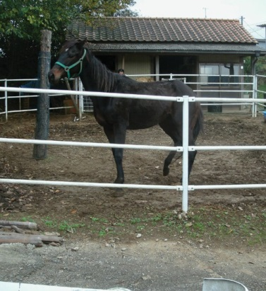
On the way to the group meeting at Narita City Hall, Chikara took a detour from his normal route, turning onto a small road that went between some farm fields. After driving on a winding route, he stopped the van as the road led down a slight hill. On the left-hand side of the van we could see a large shed, around 6 meters wide. Chika- ra explained that this was the place where his horse stayed. A caretaker was busy feeding the horse, and after Chikara spoke to him, the caretaker brought the horse out into the yard. It is quite remarkable that somebody could keep a horse as a pet, particularly given the limited number of areas where it would be possible to ride the horse.

Our band (and the musicians’ host families) regularly met in the lobby of Narity City Hall. In one corner of the lobby, we had seen a larger-than-life doll figure of a shogun-era local warlord. The doll was made over a century ago by a noteworthy Japanese artist. and it rests in a glass display case. The display case includes commentary on a plaque, and the English “subtitle” text tells that this doll is pulled through the streets during festivals. When not used during the festivals, the doll is kept behind glass in its display cabinet.

On this particular day, as we walked into the lobby, we noticed the empty display cabinet.

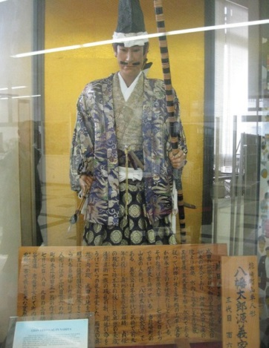
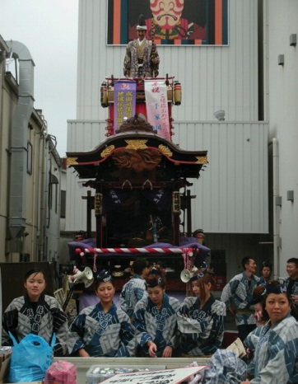
We were then driven over to the hotel, and then after meeting with Aoki-san and other Chiba-Wisconsin people, we were led down the narrow street towards the Buddhist temple. When we followed the street around a bend, there in a side alley we saw a gaudy multi-tier
festival wagon. Up on the top tier - probably 18 feet or 6 meters up - was the “warlord” doll, looking down fiercely as he held up his sword.

Around the wagon was the crew of local people who would be handling the wagon and riding on it. They were wearing traditional-themed attire. They were happy to pose for our cameras.

After traveling another short block down the street, we passed first one stage area, and then came to another that was adjacent to a rest room facility. A traditional flute-dance-and-drum group was warming up in the street,

with their larger drums held on poles that were supported by two guys. One guy would be flipped onto his back so that the drum was between the two musicians. The upper drummer would have high wild strokes with his drumstick, giving the illusion that he was thrashing the drummer who was underneath the drum. Then, the upper drummer would get up and pull strongly on the drum’s pole, helping the lower drummer to quickly get to his feet. After some mock struggling (the two drummers leaning in towards the drum, giving the impression that each was trying to push the other back-
wards), the drummer who had formerly been uppermost would now drop to the pavement, and the drummer who had been former the underdog would now be leaning over the drum, giving wild strokes.

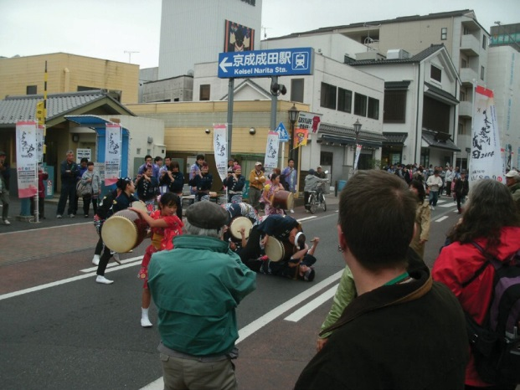
The drum group in the street

This group had come to Wisconsin a few years ago as part of a Chiba-Wisconsin Association delegation. They are well known in Chiba, and they have made other trips abroad besides the “CWA” trip. The dance routines that they perform, and the stylistic drumming techniques used, give this group great visual appeal.

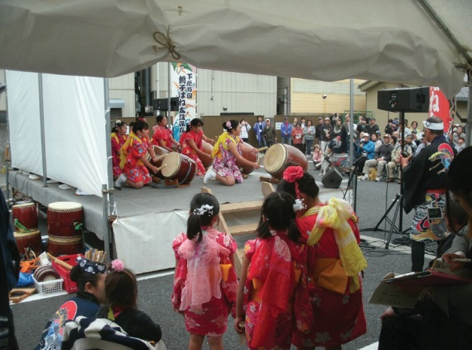
These drummers then went tot he stage to start their act. We went into an adjacent “stage prep” tent and quietly checked tuning, and then went to another tent which was backstage from the perfor- mance stage, where we waited for turn to perform.

As we were about to begin tuning, we were joined by Marutani Miki and her husband. Miki traveled to Wisconsin as part of the Chiba- Wisconsin Association Delegation for 2013. She is a public health nurse and she had stayed with Don and Bobbie in October 2013. Miki is now working in Osaka. She had traveled all the way from Osaka to hear our band, and to say hello to Bobbie and Don. We were honored by her actions.

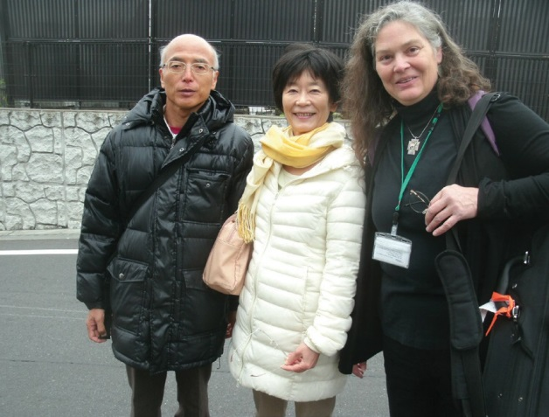
Our band was scheduled to perform from 10:30 to 11:00 AM. The drum group got a call for an encore, so we got off to a slow start. We began with Sliabh Russell while the sound system was still being set up. By the time we had gotten to a song, the sound system was up and running very well, and I noticed that a pair of high-quality video cameras were filming our performance.

Our first song was Holy Ground, and clearly the English-speaking au- dience members (including other members of the Wisconsin-Chiba delegation) were shouting their “Fine Girl you Are!” response, and everybody in the audience was spontaneously clapping along. I’m not sure why the songs prompted the audience members to clap, but the
same thing had happened when we performed for the high school Brass Band Club on our first day. Our audi- ences at the two junior high schools had been a bit more reserved, but they also ended up clapping to the songs.

As we started performing the next tune, a lot of our audience members got up to walk away. I was wondering if we had done something wrong, but then I noticed that both video cameras were being hastily covered up with clear plastic sheeting. That’s when we realized that it was starting to rain. We were comfortably dry under the stage’s “rain roof ” tent, but our audience was getting soaked. It was encouraging to see a large part of our audi-

ence putting up their umbrellas or putting on their raincoats, and staying with us as we continued the perfor- mance.

We were asked to do an encore, and we obliged with Frieze Britches. The audience was rewarded not only by the encore tune but by a stop to the rain. When we were done, we were able to quickly clear the stage to make room for the next group that needed to set up. The next group was a flute-and-drum traditional musical group. As we got off the stage we were given a big round of applause by the incoming group.

After meeting again with Miki and her husband, we were ushered by Yasuko-san over to a side street’s building, where we were provided with lunch. Miki and her husband were able to join us because Aoki had made “special diet” meals for Bobbie and Debby, and so Miki and her husband were able to have some food that had been pre- pared for the musicians. (Arigatto gosaimas, Yasuko-san!)

After lunch, we carried our instruments to a “preparation tent” at the stage where we were to do our afternoon perfor- mance. This gave us a chance to wander through the festival for a half hour or so, before re-tuning and doing the after- noon gig. When we were back on the street, we encountered a number of festival wagons being pulled past us by large crowds of people who were first carrying, then pulling heavy ropes that were around 2” diameter. There must of have been a small fortune worth of rope for each wagon - easily 120 feet (or, 40 meters) of rope at each corner of each wagon. (There were also ropes coiled up on the “back” part of the wagon, because the narrow streets do not allow a wagon to be turned around.) The crew pulling the ropes were being led in cheers of “Rashah” (or “Washah”) by a cheerleading guy with a bull- horn. (This cheer is similar to “hooray!” and is intended to

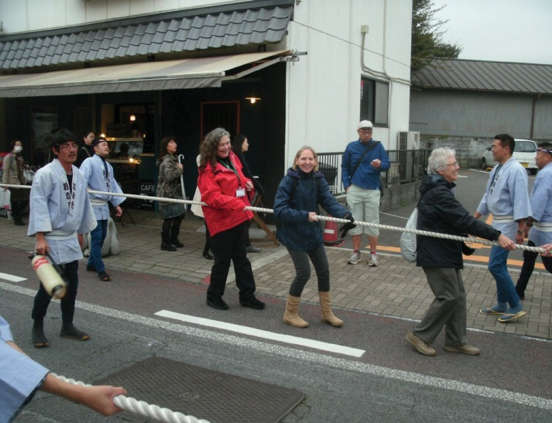
Bobbie, Deb and Sharon get to work

build up some anticipation and excitement in the onlookers.) At around the same moment in time, Aoki and I saw Bobbie, Debbie, and Sharon Durtka pulling on the rope that was across the street from us. Walking along, I found a gap among the crew pulling the rope on my side, so I got into the gap and joined in the pulling. I figured that I had plenty of time before we needed to be back with the band for our afternoon gig, so I probably pulled the wagon for at least a full block. Then I gave up my spot and went back to the stage for our afternoon gig.

We saw a total of six of the festival wagon being pulled down the street. Most of these had the shogun effigies (dolls) on the top tier of the wagon roof. Clearly there is a lot of friendly rivalry between various cities in regards to each town’s favorite legendary historical figure.

When we got to the afternoon’s stage, we found another flute-and-drum group was performing.

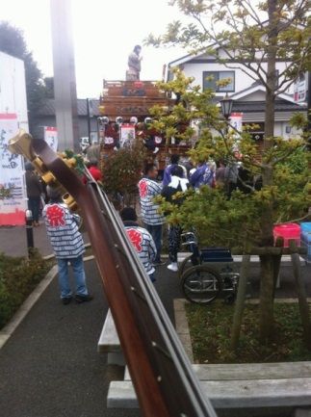
Once we got onto the stage, we had to wait for one of the festival wagons to move down the street. Since the wagon’s “trad music” band was being amplified by the wagon’s sound system, the wagon would have been a bit of a distraction for our audience. Once the wagon was moving down the street, we were able to start our performance. We started out with Holy Ground (because it gets the audience quickly fired up), and the sound system was working splendidly. We then continued with Three Marches. The dulcimer solo on Laird of Drum Blair was a bit “sketchy” on the first time through, but was absolutely “solid” on the second time through. One factor contributing to the solid- ity was the non-varying tempo of the rhythm section of the band - they were holding a great tempo, which was a very good support for the dulcimer player.

For the band’s second song, we did The Craic was Ninety. By singing this song at a moderate tempo, we hoped that those in the audience who had some skills with spoken English would be able to follow the thread of the lyrics. There was no rain, and the audience (which was a nice sized group) was present for the whole
performance. We weren’t sure if an encore was called for, but decided to do Frieze Britches again as a wrap-up.

After this second performance, we quickly cleared our stuff from the stage. (That’s one thing that we have learned from sharing venues with other bands - it can be very aggravating to be a “follow-up band” and watch the preceding band go through a needlessly leisurely take-down while the audience finally gets bored and leaves.) Once we were in the “back-stage” tent, we were able to pack up our equipment. But before making the trip back to the hotel, we got to watch a traditional flute/drum/dance group where the dancers were men dressed up in dragon costumes. Apparently some sort of story was being told through a ceremonial dance, because two of the “dragon” dancers stood still, watching the ground, while the first dancer did a long solo dance. Then the other two dancers joined in.

Not wanting to be burdened by carrying our instruments around all day, we went back to the hotel, where we were able to collect our suitcases, check in, and deposit our belongings in our rooms. (Some of us ended up back in the same rooms that we had occupied on our first night in the hotel.) It was a great convenience for us that
we had been lodged in a hotel that is within a short walking distance of the festival. (Our thanks to whomever had the foresight to book us into the Hotel Mercure.) Then we went back to the festival. While the other guys in the band changed from their kilts into casual attire, Bobbie and Don decided to remain in our performance garb (Bobbie’s dress with lots of “Celtic knot” designs, and Don in the kilt.) As we walked past the train station plaza on our way toward the festival area, some Japanese people looked at us and said “Idlish Musicians,” and pantomimed playing a fiddle. This might have been on account of Don and Bobbie still being in their “band” costumes, but other musicians had a similar experience while been in non-gig clothing. So, we must have made a good impression.

As we went down the street we kept encountering the decorated wagons with the ‘rope pull’ teams in colorful outfits. Each wagon has a sound system, and the musical instruments are equipped with “pickup” microphones. Between the cheerleader’s bullhorn and the band’s sound system, you can hear the wagon coming at the same time that you first see it.

During the walk, Bobbie and Don met up with others in our group - other musicians, and also the band’s Japa- nese hosts including Yasuko Aoki and one of the other “CWA” people. There was an incredible amount of Japa- nese folk culture on display, mostly traditional, but also some contemporary acts. The only aspect of the street that didn’t move around was the set of “zodiac statues” that lined the street - a snake, a rat, a pig, a dragon, a dog, etc. Otherwise, there was a constantly shifting blend of both traditional and contemporary Japanese performing groups

The lower end of the street (away from the performance stages and towards the Buddhist temple complex) has a lot of shops. Around a third of them sell food, a third of them sell miscellaneous items (particularly items that a traveller might be interested in, like kids’ backpacks or umbrellas), and the rest sell souvenirs. Bobbie and Don were trying to find a shop where we could buy some gifts to bring back home, and we found ourselves in a “Pa- rade of Mascots,” where people going down the street were wearing costumes of various characters. The typical “mascot” character has a width that is half of the character’s height, with a general appearance that would be suit- able for a child’s stuffed toy. In looking at the costumes, I was wondering how the person inside was able to see out. Most “mascots” were accompanied by an assistant. The mascots were quite colorful, ranging from the blue “stuffed airplane” of Narita to a bright red “bird” character, etc.

While they were in one shop looking for gifts to bring home, Don and Bobbie met a Japanese man in a medieval-era style tradi- tional robe. Coming up to Don and pointing at the kilt, he bel- lowed “Scotland?” Don grinned and nodded. Then the gentleman
pointed to his own outfit, and with a big smile, he bellowed “Japan!” Don and Bobbie gave him a big ‘thumbs up,” and then got a store clerk to take a picture.

As they worked their way down the street, Don and Bobbie heard a voice calling “Bobbie!” Looking up, they saw the Higher Education part of the WCI delegation in the second floor of a tea shop.
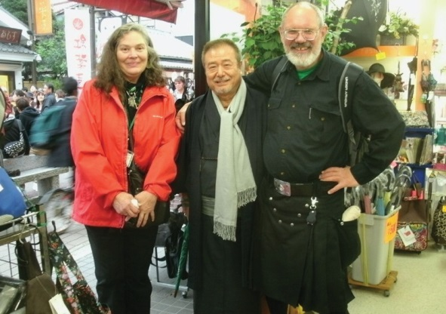
“SCOTLAND? JAPAN!”

Most of the band’s musicians eventually worked their way down the street to the temple area, where the noise and crowding were significantly reduced. Things were abruptly quiet as one walked through the main gate and up the 53 steps to the plaza that surrounds the Main Hall. The plaza area was nearly deserted - we saw almost nobody else. Don went to the Main Hall’s doors, tossed some coins into the offering box and offered a prayer of thanks for a truly wonderful day and a wonderful week. We had been extremely fortunate to be able to have been the Cultural Exchange Group in the 2014 WCI delegation.

After giving thanks at the Main Hall, they went towards the right to go to the garden area. We found that two other couples in the band (Deb and Joe, and Pam and Dave) had also ended up in the gardens. We all felt that it was necessary to “unwind” after the loud music and bright costumes of the festival.

We did some strolling in the quiet of the gardens. From the tranquility of our surroundings, it would have been hard to guess that we had been in the noisy street of the festival. At one point, we came across an old wooden house which was tucked into the back side of a hill. Near this house we saw a small stream, and across the stream was a hollowed-out space in the side of the hill which made a small echo chamber. Aside from seeing only one other person, the band’s musicians had the whole area to themselves.

We needed to be back at the hotel by 4:45 pm, so that we could be on hand for the formal Farewell Dinner (which started at 5:30 pm). On our way up the street, we found that the wagons were still out, but now the crews had to work very hard to pull them up the steep hill. Where we had encountered the wagons earlier in the day, the street was quite flat, and lots of people who were attending the festival were happy to join the crews on the ropes. But now the crowds were thinning out, the cheerleaders were no longer shouting “Washah!” and the wag- ons were on the lower part of a hillside. The wagon’s crews had no assistance from onlookers as they worked by themselves. The lanterns on the wagons were lit up, giving an added festive touch to the gathering dusk.

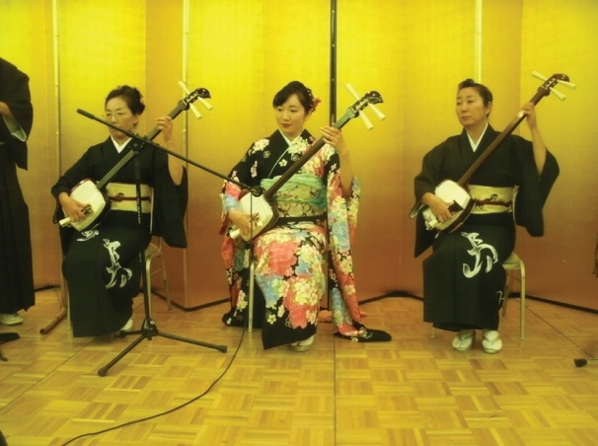
At the hotel, the Farewell Dinner was a much bigger event that we might have anticipated. Around half of the band had attended a simi- lar dinner the year before in Milwaukee, which had taken place at a favorite Chinese restaurant in band’s home town of South Milwaukee. However, the dinner at the Mercure Hotel was in a large hall, and it included a traditional music group doing entertainment.

Members of the band were split up to give the group as wide a pres- ence as possible at the dinner. Don was sitting at a table with two board members of the Chiba-Wisconsin organization (neither of whom spoke English) and a representative of Kikoman (Yoshiuki
Nogi, who has excellent English skills). Also at Don’s table was a gentle- man from the Chiba Prefectural Government, who had grown up in

Performers at the Farewell Dinner

9 November 2014 (Sunday):
Mark Wooldrage

Our last full day in Chiba was a free day, and it had taken a lot of thought to figure out what to do. It’s not a simple choice: there’s far too much to see, and not enough time to see it in one day. After much consideration, the band decided to make a day trip to Tokyo, to experience the capital city. Chikara and Yuga Tsubaki had both said that they wanted to come along with us, as well. As the farewell dinner for the Wisconsin Chiba Delegation, Kimiko (who splits her time between Japan and Madison, Wisconsin) said that she would be willing to write up an itinerary for us, and give us a guided tour around Tokyo. As fun as wandering around by ourselves sounded, having a guide sounded like a good idea.

We set off in the morning to the rail station to get our rail passcard. The trip to Tokyo is about an hour, and then we woul be taking several rail trips in Tokyo itself to get to the different areas. Kimiko figured that about 3000 yen would be enough. To us, that seemed like a great deal: round-trip transportation and mass transit for the whole day for a little less than $30? We wish we had mass transit options like that back home!

Once on the train, we settled in to watch the countryside pass by. The train we took was a commuter train, and not an express, so it stopped at many stations along the way, and the train gradually became more crowded. However, since this was a Sunday, the train never got unbearably full. Kimiko told us stories about how full Japa- nese trains could become. As the trip went on, the landscape changed over from farms and spaced out houses to a built up urban landscape.

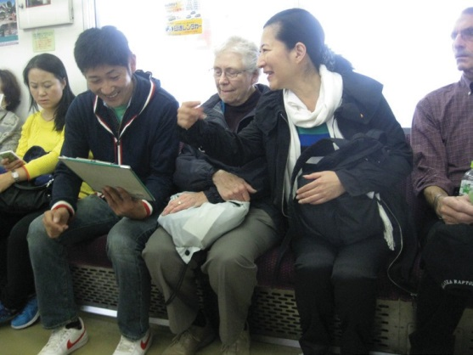
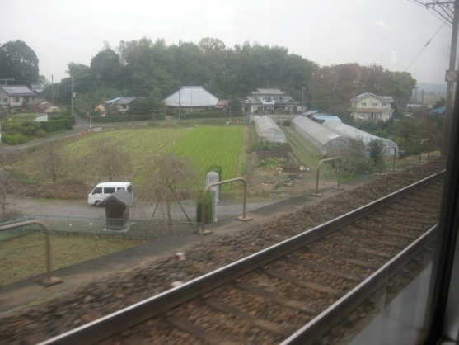
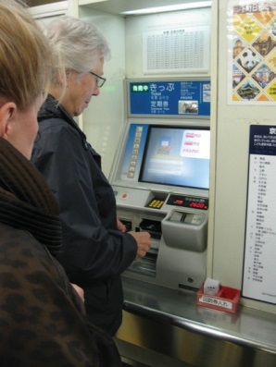
Buying a rail card Chikara, Sharon and Kimiko on the train Scenery on the way to Tokyo

Our first stop was Asakusa Station, and the Senso-Ji temple. One of the first views that greeted us on the street, was a view of the huge Tokyo Skytree, the tallest structure in Japan. Yuga had told us about it when we were talk- ing about things to see in Tokyo.

We walked across a street, and then we were at the main gate. The train may not have been crowded on a Sunday, but the temple certainly was, with a huge temple complex. We walked down the row of shops towards the temple, trying to keep each of us in sight so as to not get lost. We had an hour at Senso-Ji, and were amazed at the scale and beauty of all the buildings.
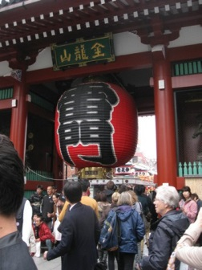
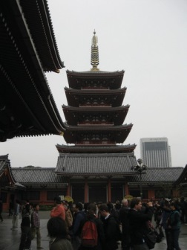
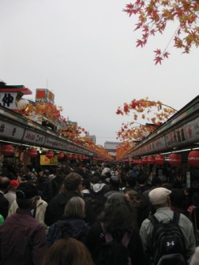
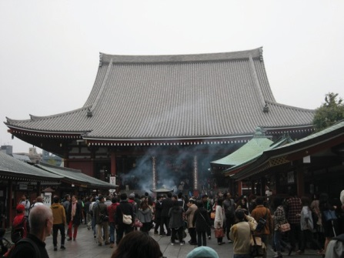
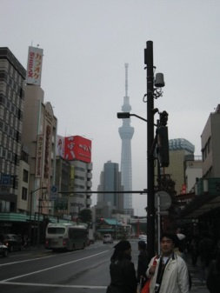
Tokyo Skytree Main temple gate Five story pagoda Hundreds of shops The main temple building

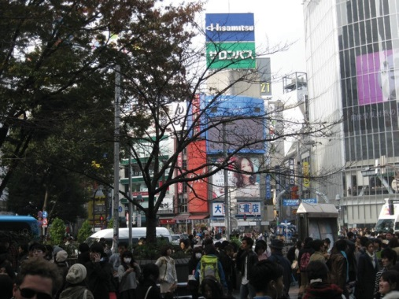
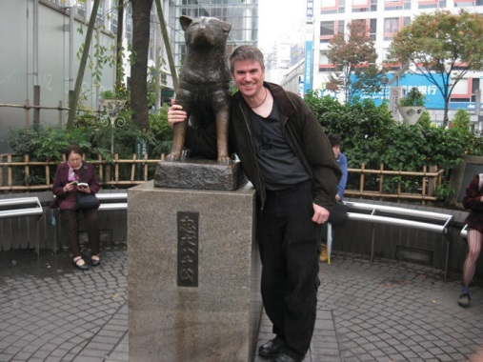
All too soon, it was time to head off to our next destination: Shibuya Station. This area could teach Times Square a thing or two about being crowded, flashy, and very, very impressive. One of the more unique parts of this area is the pedestrian crossing. At one point, all traffic is stopped, and the entire five way intersection is open for pedestrian traffic, truly unique.

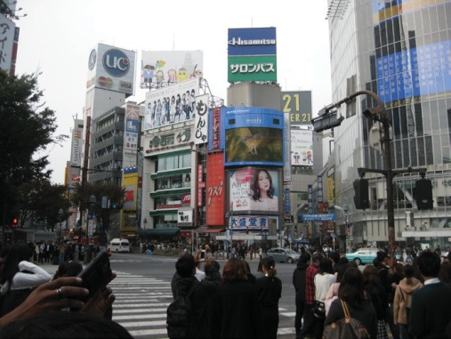

Shibuya Station
Another view of Shibuya Station Hachiko and Mark

Another stop at Shibuya Station was to the statue of Hachiko, the dog who waited for his owner at Shibuya Sta- tion for 9 years. It’s a very popular meeting spot, and there was a line of people to get their picture taken with it. There are five exits at Shibuya, and the one with the statue is known as the Hachiko Entrance/Exit. While we were in Shibuya, we had the opportunity to visit the second floor Starbucks to watch the traffic and pedestrian patterns, or visit a nearby electronics store.

Lunchtime! We took a short walk to a nearby farm-to-plate restaurant called Eco-Farm Cafe 632. It sources many of its ingredients from local farms, and had wonderful food. I found it interesting that this was the only restau- rant we visited that didn’t have chopsticks, only knives, forks and spoons.

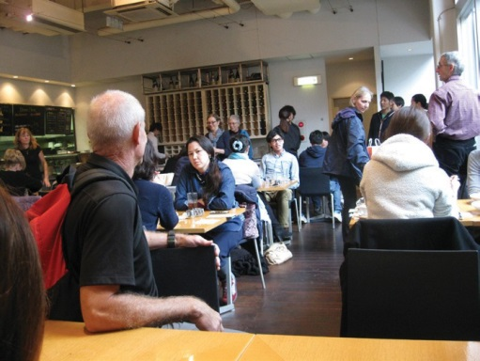
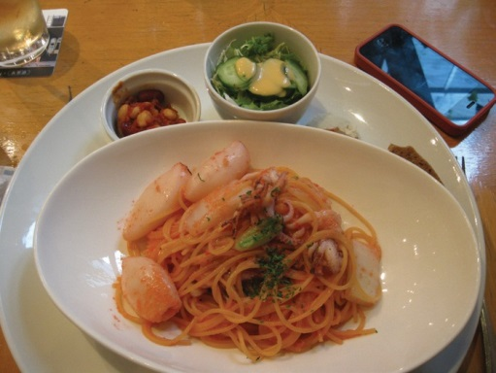
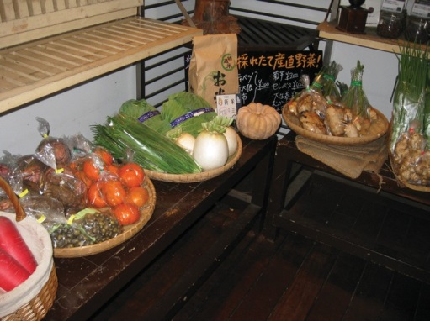
Local produce Inside the Eco-Farm cafe Pasta with squid

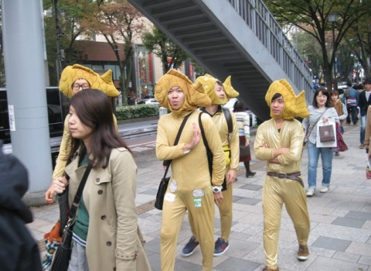
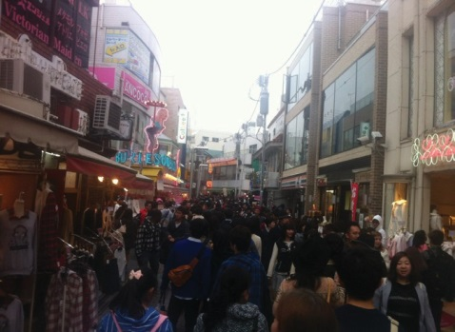
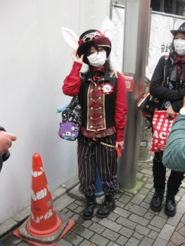
After that, it was another walk to the train station, and a short ride to the Harajuku station. Here, we would get to see some of the shopping areas. The street was a wide, divided street, with pedestrian walkways over it, and was lined with upscale stores. Part of the group went to the Oriental Bazaar, an art gallery and store, while I walked with Chikara and Yuga around the backstreets of the area. We walked to Takashita street, which is an area known for its trendy small shops, and even trendier dressers, We saw many amazing outfits while walking around...and more than a few puzzling ones. After we saw a group of five men dressed in fish outfits, I asked Chikara, “Why?”. He replied, “Don’t know.” It was fantastic.

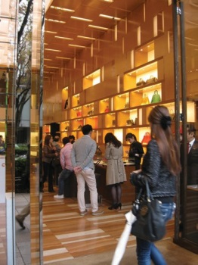

After the bright lights and crowds of Takashita street and the shopping district, we walked to toe Meiji-Jingu shrine, a Shinto shrine with a large garden. I found it amazing that such a short way from the crowds and shop- ping was such a quiet and serene place. It was, and is, one of the most incredibly beautiful places I have ever seen: landscaped, yet not. Perfect. We walked the long path to get to the center of the garden and the shrine within, walking past containers of sanctified saké. We were there at the end of the day, so the grounds were being closed...but we had enough time to be able to walk through and experience the shrine and gardens.

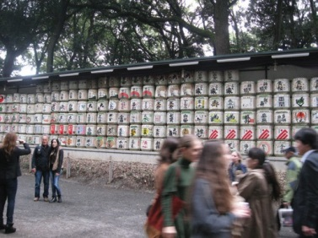
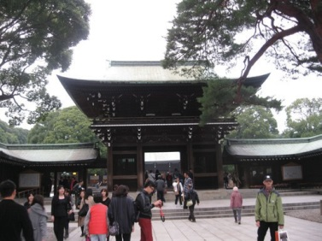
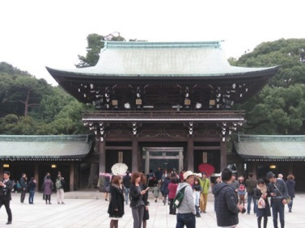
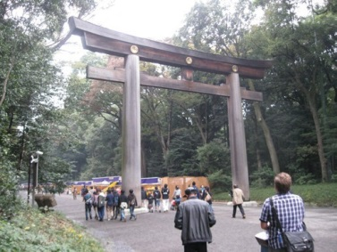

After leaving the gardens, we had an opportunity to shop at the Takeshita street 100yen store...essentially, a Dol- lar Store. I had visited the Dollar Store in Narita, and thought it to be similar to the ones we have in Wisconsin. However, the one on Takeshita street was impressive: it had a huge range of goods, and it was also four stories.
I was impressed to find a large number of ceramic cups and bows that were made in Japan. We all did a lot of shopping for gifts (and for ourselves) before we headed off to the next destination.

After that, it was another short rail ride to Ryogoku station for dinner at Hananomai Ryogoku, a sumo-themed restaurant. At one point, the building was an actual sumo gym. It still has a sumo ring in the middle of it, where they occasionally have demonstrations. Tonight, there was no sumo, but there was a demonstration of traditional Japanese drumming. I found it interesting how tipping works for performers in Japan: instead of a hat, the per- former will wear the bills on his shirt, on display. It’s an impressive sight for a good performer, his shirt covered with 1000 yen bills.

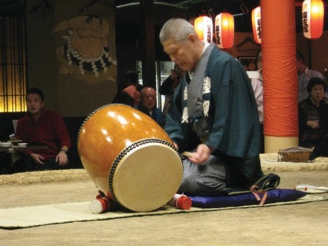
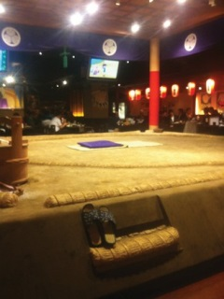
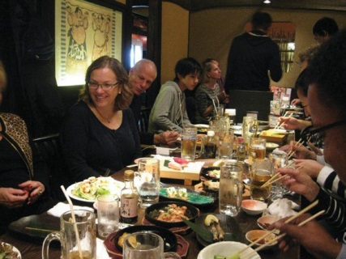
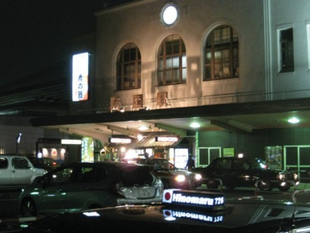
Dinner was similar to the izakaya restaurant the Tsubakis had taken the men to on Friday: the menu was an as- sortment of smaller dishes, and we all ordered one or two things, which we also shared with the people around us. Once again, an incredible end to the day.

After that, it was time to catch the train back home. It was a long day, and more than a few of us fell asleep on the return trip. Kimiko had planned out the fares perfectly: we ended up having 500 yen remaining on our cards when we returned to Narita, which the attendant at the rail station was able to refund to us when we turned in our rail card.

Kimiko did an incredible job of setting up a whirlwind tour of Tokyo for us. We all agreed that we saw far, far more of Tokyo than if we had tried to do it ourselves. The Tsubakis were also great guides, walking around with us and showing us things that we might not have noticed otherwise. Truly a day to remember for a lifetime.

Host report: The Shinozake and Fukuda Host Families

Bobbie Groth

On Tuesday we met our host families in the lobby —my first family’s mother was Makiko, who speaks very little English and I no Japa- nese, so it was at first a challenge to communicate. She has a phone app here she speaks what she wants into the phone, it translates into English, then says it out loud to me. Very clever, but not always understandable. I think I made them late to the evening activity, which I know is a big taboo, because I just didn’t understand what she was trying to say to me—that it was time to go! We were going to the head of the dance school’s house, which is where the men are staying. It was a lovely pot luck, and then the tables were cleared out of the way and the children came to perform. They asked us to perform to, but it was conveyed to me unclearly, and I did not have my foot support or my neck support with me, so it was very dread-
ful. Add onto that jet lag and I have a very sorrowful memory of that evening! Note to any future instrumentalists: make sure you have time TOGETHER to rehearse and warm up each day. It was deadly not having that because we were all staying in separate accommoda- tions and there was no warm-up time planned before nearly all the performances.

My first host family consisted of Makiko Shinozake, her husband Shintaro, their daughter in the dance troop Honoka, their four year old daughter Arika, and their two year old son Toa. They live in a charming apartment complex with onsite parking, high outside cor-

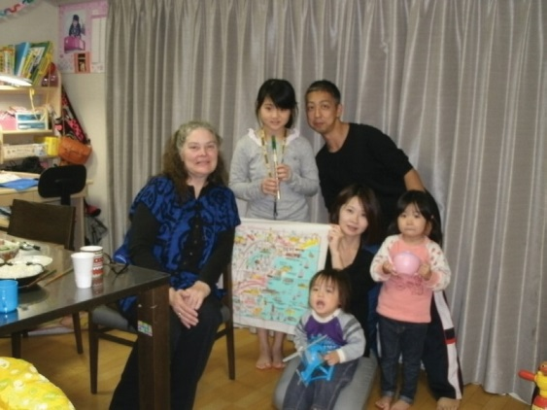
Bobbie with Shinozake family: Bobbie, Honoke, Shintaro, Makiko, Arika, Toa

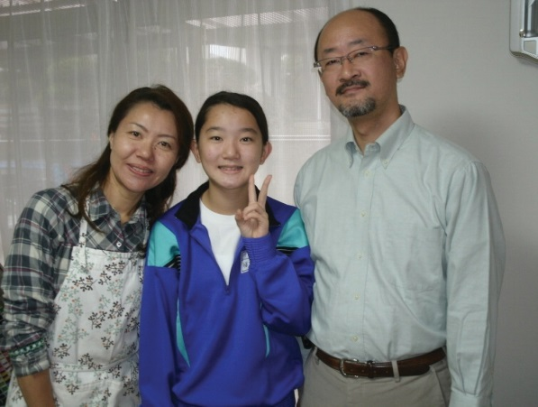
Fukuda family: Mina, Shiho and Kusashi

ridors accessible by elevators. The apartment is very modern, sleek, and efficient with two bedrooms by the front door, a bath room, a toilet room, a Pullman kitchen opening into a dining room that holds a table but has the children’s desk and toys and books on the perimeter, also a TV set. There is a traditional room with rattan floor and sliding walls. It stays open during the day and the children play there. At night the walls are shut and the futons spread about and all three children sleep there. The parents sleep in a bedroom off of that room next to the kitchen. Everything was very modern in terms of facilities, and the futons were so amazingly comfortable. I slept so well on them—what a change for me! I don’t sleep that well at home on the bed!

Shintaro knew a little English and is a very gregarious person. He loves his car, and was eager to talk about all kinds of things. We did our best with the phone translator, and in no time I felt very comfortable there. I felt funny, because I am so used to helping in the kitchen and helping with children, but it appeared everyone was most comfortable when I sat and had my tea and was waited on!

The children were absolutely charming. It was my general observation that children are allowed to be children and are not glued to the television all the time. They are very polite while at the same time very nurtured and cuddled. The reserve on physical contact that adult Japanese have with each other is not in effect around chil- dren. The parents spent lots of time being affectionate to all their children, even the older girls, laughing and talking with them, cajoling the younger ones gently if they were balking at doing something. It is part of the ex- treme politeness, their way of correcting their children. I loved it. In the Shinozake household the four year old and two year old played a constant game of cat and mouse, laughing hilariously, chasing each other, giggling and falling all over each other. Neither parent told them to be quiet, but accepted their play as normal. It was very

refreshing! Both parents dole out lots of kindness to their children. When Mama was busy with dinner in the kitchen then Honoka got out the origami papers and began to amuse her brother and sister. Then, when dinner was ready, they all three picked it up carefully and put it away—they didn’t even have to be told. Before they did that, Makiko admired and praised their work. Honoka was a darling girl, right at her mother’s elbow, helping the family through its routines—although if she was not happy, she would lean against her Mama or Papa while the situation was resolved.

Makiko was up by 5:00 am, ironing the children’s school clothes. Honoka goes to a middle school, Arika goes to a “kindergarten” which is a daycare, Toa is cared for by his grandparents on a small farm at the edge of town.
Both girls wear uniforms to school. Honoka was up early and was the first one out the door. Both parents said goodbye to her, and knocked on my door, expressing that she was leaving so I could say goodbye too. This was a morning ritual in both families, and very pleasant! Makiko has many things to do all day to care for her family. It seems that all children routinely start daycare/kindergarten at a very young age. Despite long hours of separa- tion, the families are very devoted to each other and very close.

Even the first day I was there, Honoka tapped lightly on my door and served me my first tea of the morning on a little tray! This was my signal that the family was up. I had gotten up at 5 to take my shower as I didn’t want to be in the way of their morning routines. When I came and sat at the dining table, Makiko introduced me the very first day to a home cooked, very sumptuous Japanese breakfast. They didn’t have the typical western fare, but served about 5-6 different things in small bowls—fish, soup, eggs, vegetables, rice, meat—very much like
a Japanese full lunch or dinner. It was wonderful. I love the taste of Japanese food, and I love the freshness. Makiko said they are fortunate to have the vegetables her parents grow, but it seemed to me that everything is based on fresh vegetables no matter where we were. The second morning it was Shintaro who tapped on my door and served me tea. I decided right then and there that I would adore being a grandmother in this culture!!

After all our activities on Thursday, my second host family picked me up at city hall and took me home to their house. I had met Mina, the mom, a few times, so that was great to see her as a familiar face. The Fukuda fam- ily consists of Mina, the wife, Kazushi, the husband, and their Junior High aged daughter Shiho. They also have a college age son, Shun’ichi who I did not meet, and an adult daughter, Misato, who was away traveling with her sheltered workshop group. The Fukuda family live in a beautiful house with a nice garden to one side, on a quiet street of like-houses. I was set up in the traditional room with the rattan floor for my bedroom, with my futon to be taken out each night. Once again it was very, very comfortable. There was also a sitting chair in that room
which was good for me: I can sit on the floor, but I am not as adept at doing everything in a squatting position as my hosts! The Fukuda family congregates mostly in the room that is off the kitchen, which consists of a kitchen table, a couch, and a television. It was so pleasant to sit at the kitchen table and hear Mina and Shiho laughing
at their work in the kitchen—once again I felt like a queen, as I was not to lift a finger, but to drink tea! Mina speaks some English, and it was fun to join in the laughter together! Despite language challenges, I had some conversations about our families with both my host mothers that I will very much treasure.

That first night we had an amazing sumptuous dinner, which was the pattern in their household. Mina laughs a lot, and it was a joy to hear her laughter—very friendly and comforting. Kazushi is a medical doctor at a nearby hospital, and true to form is more reserved and quiet. He expressed that he felt bad that he did not know any English, but by the second day he was a lot more smiley, so I guess he was getting used to me!! Shiho is a tradi- tional dancer with the children’s dance group. She is in junior high, and we saw her at one of our visits—she was one of our announcers! She shares her mother’s eternally joyful demeanor and is very dedicated to her school. All of the children go to school on Saturday, when they study things like music, or kendo.

The second day I was there Mina discovered I like coffee, so she made me some—she drinks it too, apparently. It was so delicious. My last night on home-stay Mina made a wonderful sushi dinner with tempura—it was so amazing. We sat around and had a very good time together. I really like the Japanese format of so many foods.

I was told that you are supposed to have a certain number of essential tastes in each meal, because they satisfy your soul. That was certainly true! They do not seem to over-indulge like American’s do. Almost everyone we saw was slender and fit, and ate politely, and did not stuff themselves. It was all I could do not to eat everything in sight!

What we can learn from the Japanese and their culture is first of all efficiency in using up things or living—they have a very low consumption rate, and things are not stockpiled in the house like our Wal-Mart culture. There are no paper towels in public bathrooms and so people carry a little towel in their purse. What a great system! So much more sanitary!! In the midst of all the Japanese manufacturing economy, the people themselves have a very simple lifestyle—no accumulations of extra things. You bathe by filling a basin and soaping up from it, then rinsing under the hand held shower. If you like, you soak afterwards in a hot tub. Water is very conserved— many of the toilets run water through a little fountain on the top as the tank is filling, so you can wash your hands there. Then that water is what goes into the toilet bowl. Such a great idea. I was fortunate that both host families had western style toilets—I don’t think my knees would get me up from the in-floor toilets! Toilet seats are heated! What a luxury to us!

The houses are all kept very cool, as energy is very expensive. I was so happy when I found this out because un- like most Americans we keep our house very cool, and I was so afraid I was going to be burning up. I was very comfortable all the time. Looking at their appliances and cars, I think I would rather have the Japanese ones— much more efficient use of space and energy. Gardens are very small, but quite beautifully cared for and produc- tive of vegetables.

I liked the houses which were generally smaller than American homes, but there was much more efficient use of space, much less clutter, not ostentatious—very graceful, utilizing natural light, with a warm welcoming feeling of spaciousness. I became so agonizingly aware of how much we Americans waste, and how overblown our con- sumption of resources is. I knew this before, but I could see it in every way up close in Japan.

One other thing I noticed was different from our culture. First, how early the wife got up to begin preparing her family’s clothes and food. But then, even in these two households with a stay at home mother and a father who worked long hours, when the father came home he would join right in to help with the children and the meal preparation. Then, at some moment when it was clear that dinner or breakfast was done being prepared, Papa was to sit down at the table and Mama and children brought him his tea and food in a way that honored him. I was put in that position of honor too. It was part of their immaculately polite home hospitality, and it was won- derful to be the recipient of that cultural tradition.

I have taken so many wonderful memories home from Japan, but my favorite ones are those of my host families and all the other Japanese people who made our trip such an amazing experience.

Host report: Shion Hara

Pam Uhrig

My host was Shion Hara, who was a member of the Japanese Dance group that visited Milwaukee in the previ- ous year. She is in 5th grade at the elementary school in Narita. She lives with her mother, Yuka and her father, Kiichi, and 2 cats.

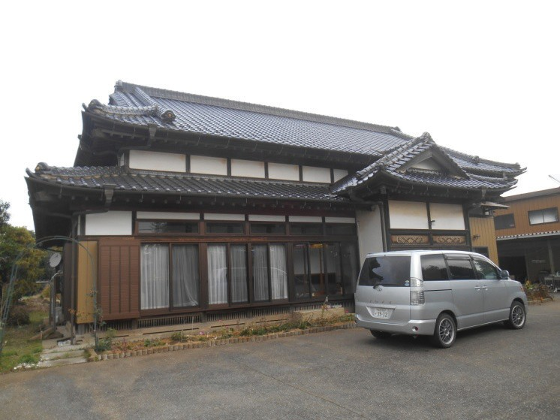
On our first day together, Yuka met me at the hotel. Her lovely smile stayed with us all day as she escorted me to all of our activities. She was always ready to help; with the kimonos, the lunch at the restaurant, and following our guide at the temple in Narita. She was always ready to take me everywhere in her cute little pink car.
At the end of our group activities, we drove to her home.
It was an interesting ride through the country and took
about 20 to 30 minutes. The house looks to be a very tradi-
tional style Japanese home. We left our shoes at the en-
trance and I was given a pair of slippers. Yuka showed me
my room which was a partitioned section of a large room
with tatami mats. There were blankets on the floor to pro-
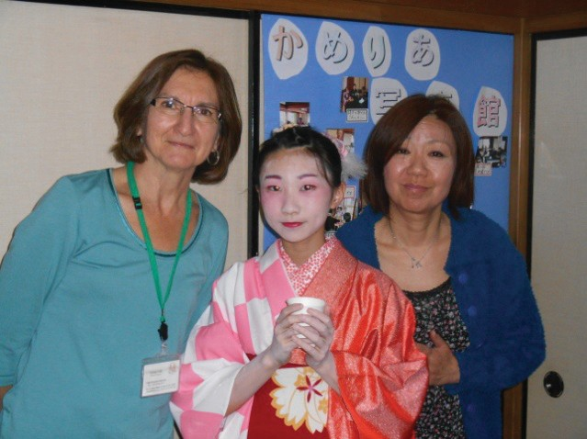
tect the mats and Yuka put up a small table and chair for
me to use for the four nights I would be their guest. At the
time it was so foreign to me to be on these mats in a room
that was surrounded by decorative panels and no bed.
One shelf had a few dolls dressed in traditional kimonos
and there was a statue of Buddha in front of a wall hang-
ing. It was a very peaceful and comforting room to stay in.

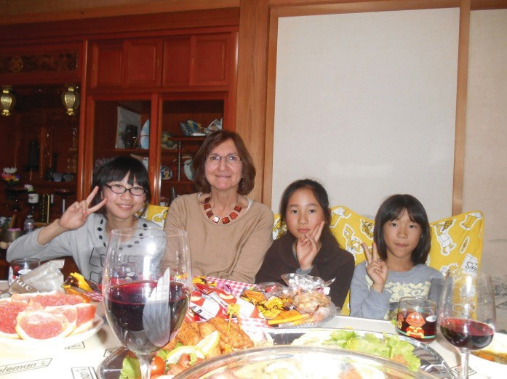
It wasn’t long before Yuka said that it was time to go. We got into the car with Shion who was very shy and quiet. We tried to communicate with the translators on their phones, but the translations did not usually make sense. We arrived at Bay House Camellia where all of the host families had put together a wonderful buffet for our group. After the meal the dancers performed fully dressed in their kimonos and the fan dance was absolutely stunning. Shion is a very graceful and beautiful dancer, and she was amazing to watch as she performed with the other won- derful dancers.

After the party, we headed back to the house. Yuka slid open a panel in my room and took out a mattress and some quilts. It turned out to be a very cozy and comfort- able bed on the floor. The wall panels were clear on the bottom so that I could see outside when I was laying down. It was very quiet and peaceful at night and the only sound was the meowing of the cat.

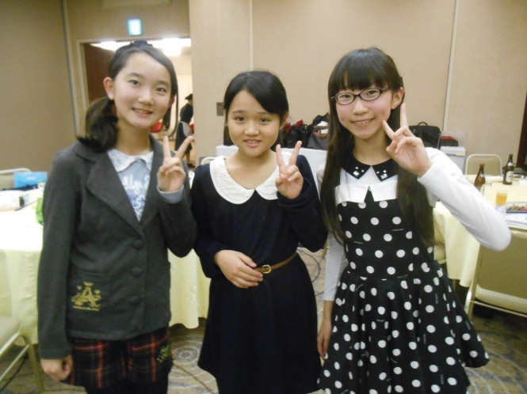
Every morning Yuka served me an absolutely amazing break- fast that included a variety of Japanese and American dishes and coffee! She made eggs perfectly with just the right amount of ham or bacon. Plus the addition of the Japanese food was an extra treat. I especially enjoyed the fresh fruit with persimmons. On our last morning together, Shion and Kiichi joined us for breakfast. It was a feast with eggs, bacon, lettuce salad and pan- cakes served with the maple syrup I had brought from WI and Hershey’s chocolate syrup!

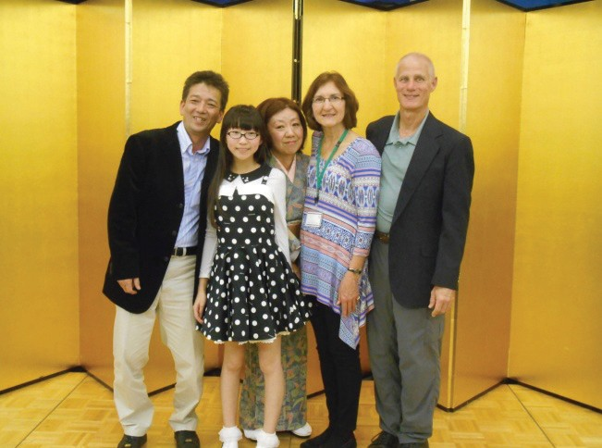
My host parents were so accommodating, always bringing me to the city every morning and picking me up in the evening. On each drive I noticed more and more of the countryside and wished that we were able to communicate more about what
I was seeing. Each evening they had something different and wonderful planned for dinner. On our first night we had a wonderful bowl of soup called Oden. It was full of many foods foreign to me and it was interesting to try and translate what each one was. Our conversations were getting more relaxed and I was happy to have a glass of beer with my meal! On our second night, Shion had invited 2 of her school friends and we had a wonderful party on a large table set up on the tatami mats. It was a buffet of rice with chop suey, and a platter of American foods. The girls were especially excited about the
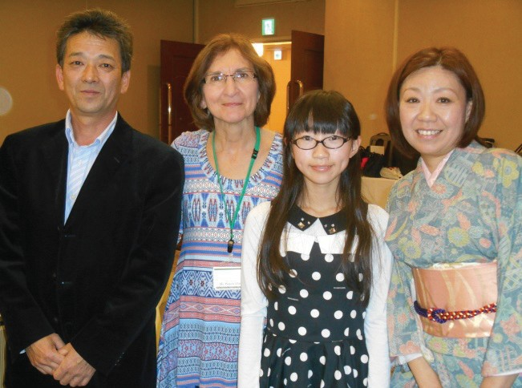
bowl of Halloween candy for dessert and the small crème puffs. On our last evening we all went to the mall which was such a wonderful experience. We had fun walking around and getting in the Christmas spirit! After the mall we went to a restaurant where little blue plates of food came around on a track and you could also order from the menu on a screen at the table. It was fun to sample so many different foods and watch Shion as she played the games on the screen (even though it was a bummer we never won!)
I can’t thank the Hara family enough for all of their generos- ity and their ability to make me feel so welcome in their home. There were moments when we realized that the lack of under- standing caused some confusion, but the communication im-
proved every day and I was glad that we had the four nights to get to know each other better. The many gifts they gave me were so personal and thoughtful and I was overcome with their generosity. Shion surprised me with a bag of goodies that she picked out for my grandchildren and the tea cup and tea was truly beautiful and will be cherished always.

After being a host for others in my home in the past, I now know what it feels like to be the guest. It has broad- ened and deepened my understanding of how the differences in a culture can be overcome with patience and understanding. I feel so fortunate to have been their guest and would not have changed a thing. Thank you Chiba Wisconsin for the amazing experience.

All of the men in the Culture Delegation stayed with the Tsubaki family (Chikara, the father, Rie, the mother, Yuga, their teenage son, and Wakako, the grandmother). Our housing arrangement was unique in that we weren’t actually staying at their house, but at the Day House Camelia, their business. The house is in a business/resi-
dential area, and faces a moderately busy road. On the first morning there, we took a short walk around teh neighborhood, and saw the mix of everything in the area: houses, apartment buildings, conve- nience stores, gas stations, and restaurants.

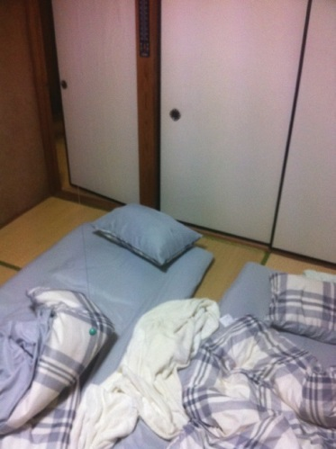
Chikara, would stay with us through the night. Each morning, Rie would arrive and prepare breakfast. They are incredibly gracious hosts, and worked incredibly hard to take care of us. They also took care to point out things that were uniquely Japanese in our food and housing. Each night, they prepared the bath for us, so we got to experience a Japanese bath.

Host report: The Tsubaki Family

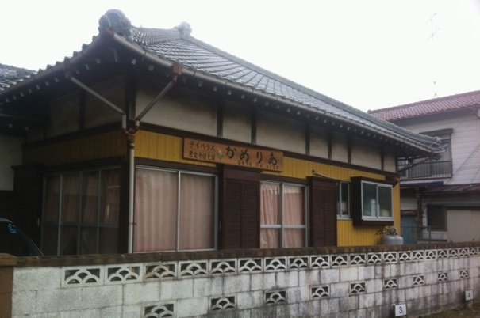
Mark Wooldrage

We were set up with sleeping accomodations, two of us to a room. Don and I slep in a room adjacent to teh kitchen (which usually serves as a small dining room), and Joe and Dave slept in the room in the back of the
house. The floors in most of the house were tatami mats (with the exception of the main hallway). It was incred- ibly comfortable.

Our sleeping arrangements

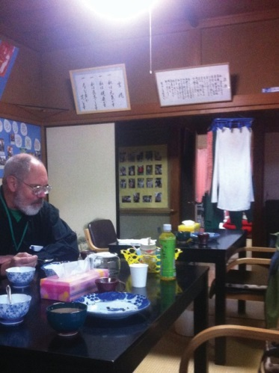
Breakfast in the main room

Over the week, we learned to communicate well with each other. The Tsubakis understand spoken English, but don’t speak as much. We made use of smartphone translation apps, and began to get the knack for how to use them to get our thoughts across. They don’t work perfectly, but they help a great deal. (Since returning, I have begun studying Japanese in earnest, and I’m amazed that the translation apps work at all, with how different English is from Japanese).

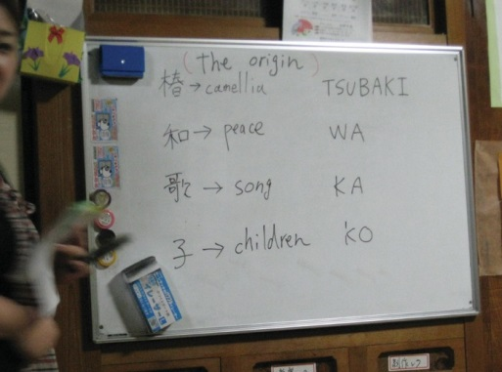
One evening, the Tsubakis explained the meanings and characters behind their names. We learned that Tsubaki means “camellia”, a kind of flower common in Japan…and one that we had seen that day at the Chiba folk museum grounds. That led into an interesting discussion about names in general.

One of the topics that came up one evening was what to do on our free day. We were all having problems deciding what to do on our free day, so we asked the Tsubakis: if there was one thing that they, as citizens of Japan,
would like a visitor to see, what would it be? It took quite a bit of thought and discussion, but their answers were: Mt. Fuji (Chikara), Tokyo Disney (Rie), Kyoto (Wakako), and Tokyo (Yuga). We tried to figure out what was most reasonable with travel time, and decided that a day trip to Tokyo would be our free day activity. Yuga and Chikara decided that they would like to come along, as well…so they joined us on our Sunday trip. It was also

that night that Chikara announced that the next night (and our final night with the Tsubakis), we would go to a Japanese bar.

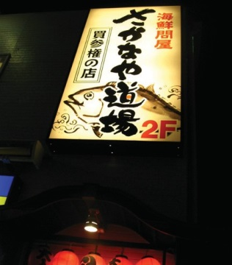
The next night, after getting home from our last school visit, Chikara handed us a writ- ten note, telling us that we would be leaving at 6:15. Time to get ready! None of us knew quite what to expect from the idea of a “bar”, as the word has a definite meaning in Wisconsin. Rie came with us, so we figured out that it wasn’t a “guy’s night out” kind of bar very quickly…but then we also picked up Wakako and Yuga. As it turns out, it was
a sushi bar/Japanese style restaurant. We had a semi-private room reserved for us, with semi-traditional seating: you could sit with your legs folded under you, but you could also put your legs under the table if you wanted.

This didn’t seem like a “tourist” restaurant (despite its proximity to the rail station), as everything was in Japa- nese. None of us knew quite what was going on, or how ordering was supposed to work, so we asked Chikara to choose for us. That’s when we found out…that was the plan. This was an izakaya style restaurant, where many small dishes were ordered throughout the evening, and we all shared them. Thus followed one of the most in- credible meals I have ever experienced. There were many calls of “kanpai” that evening.

We also learned of the Tsubaki’s love of animals. On the way to the restaurant, when stopping at the Tsubaki’s residence to pick up Wakako, Chikara went inside and brought out his cat for us. Also, during the last ride in to town, Chikara took us past the stable where they keep their horse, Tsubasa.

Later on that day, Rie and Chikara came to see us at a performance at the Narita 60 year festival. It meant a lot to us that they would take the time to come and see us.

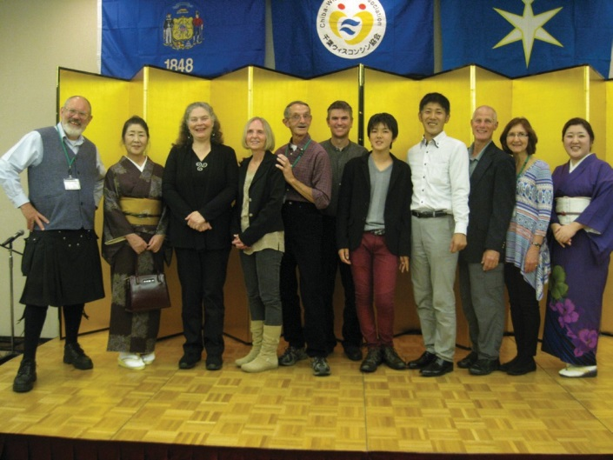
The Tsubakis were incredibly gracious hosts, and made us feel completely at home. We will always look back fndly no the memories we made in Chiba, and the friendships that were created.

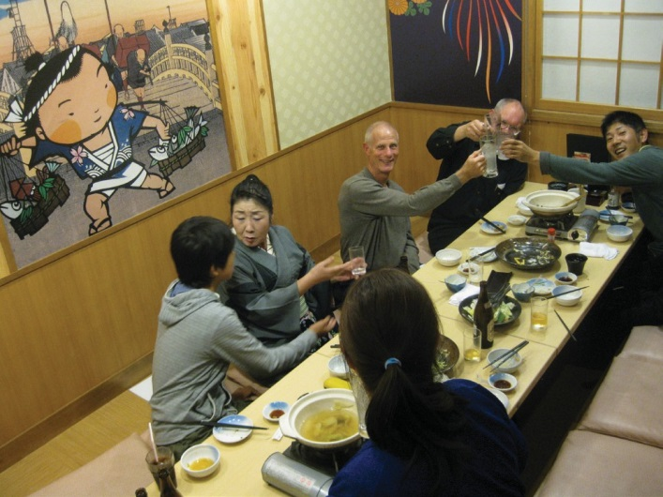

Host report: The Yoshida Family

Debbie Wilhelm

After having breakfast at the Mecure Hotel and getting my bags and violin from my room, I met my first host family, Kengo & Mami Yoshida, in the lobby. After introducing ourselves, Kengo took my bags and put them into the family station wagon. Mami very politely offered me the front seat. I was surprised to see the steering wheel was on the right side of the car. I had just assumed cars in Japan were set up the same way as cars in the US. Our first effort to communicate was in regards to the position of the steering wheel. Our first stop that day was at the Japanese dance studio. Kengo and Mami came in with me. Their daughters Ruka & Hazuki are both members of this dance studio. We all sat thru the extremely interesting
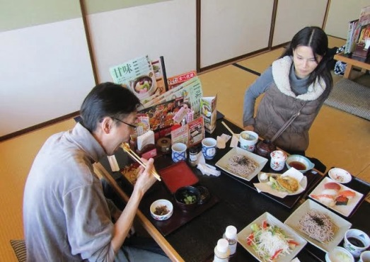
talk about Japanese dance and costumes. I was extremely surprised to hear that the wigs the dancers wear are individually made, cost around
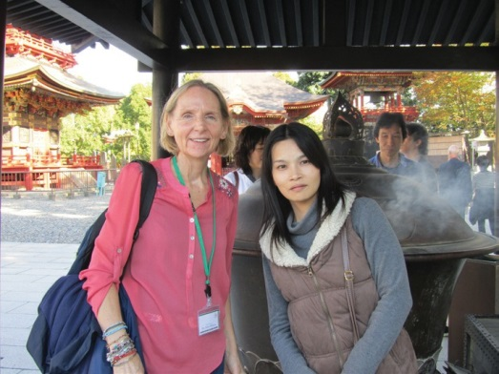
$3000.00 and weigh approximately 30 lbs. I had a greater appreciation for what the dancers are wearing during their performances. Afterwards, the culture group and host families went to a traditional restaurant for lunch where Kengo & Mami treated me to a delicious meal of tempura vegeta- bles, soba noodles and miso soup. Mami taught me the correct way to eat the noodles and dip the vegetables into the various sauces. We all laughed about my efforts trying to use chopsticks. I don’t do it the proper way but it worked for me.

After our lunch, the group left to go to the Narita Shinsho-ji Budhist temple. We had a wonderful guide who explained about the religion practiced at this temple. Mami walked me thru how to do the purifica- tion ritual before entering the grounds and also how to put incense into the large burner just before the temple entrance. After the tour, we all went into the temple to take part in the flame ceremony that was taking place that day.

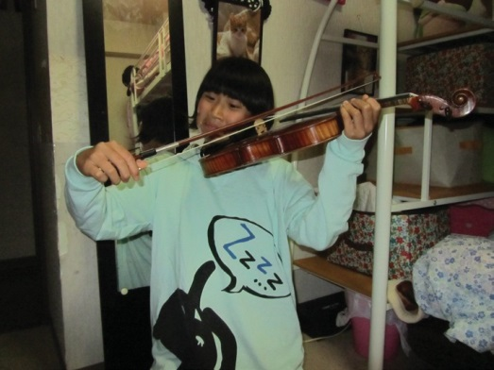
It was a full day of activity already but not over yet. Kengo and Mami took me to their apartment so I could get settled into the room they had set up for me. It was the bedroom of their twins, who were staying with grandparents the two nights I stayed with the Yoshida’s. Mami showed me around the apartment and introduced me to their two cats and one dog. I chose this time to give them the gifts I had brought for them. I explained as best I could about the photo’s of Milwaukee & my family I had put
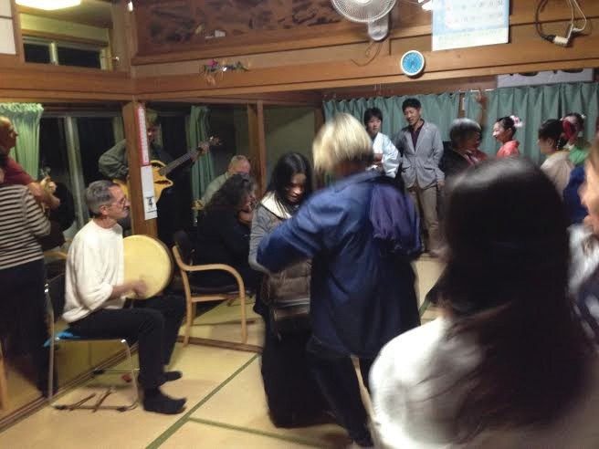
into a small album for them and the other items. One of the girls arrived home and came in the room to visit. She saw my violin case so I took the violin out and gave it to her to try. I showed her how to hold it and drag the bow across the strings. She had a good time but I don’t think she is interested in taking violin lessons. Once we all had a chance to freshen up, one of the girls joined us and we left for the host family pot luck dinner
at Bay House Camellia. The food that was prepared for the potluck was delicious. Once the meal was done, the girls and boy who belong to the dance studio put on a performance. One of Mami’s daughters performed and I was delighted as I watched the students perform their traditional dances. They were all very focused and graceful. For the final dance, everyone got up to form a circle. Fans were given out and the students

taught us how to do their fan dance. It was a great time. When this dance finished a few of the members of our band, The Garlic Mustard Pickers, played a few Irish pieces. I did not have my fiddle with me but I took Mami’s hand and pulled her onto the dance floor to teach her a modified version of an Irish dance. We had a great time. We headed to the Yoshida apartment to get ready for bed and rest up for the next day. Mami made sure I had a towel and knew where the toilet, sink and shower were and how to use each item.

The next morning I made sure I was in and out of the bathroom in time for everyone else to use it. I found out the girls had already left for school. They seem to leave early and arrive back home later than students in the US. Later I found out that the clubs many students belong to are before and after school and can last 2 hours. Mami prepared a western style breakfast for me with eggs, cereal, toast, vegetable soup, salad and juice. She tried very hard to prepare vegetarian foods for me to meet my vegetarian diet. After breakfast she drove me to the city
hall where I met up with the other members of my group for the day’s activities. I had to laugh – Mami is a very tiny woman and seeing her drive this big station wagon seemed funny to me. She is a very good driver tho and handles the car very well.

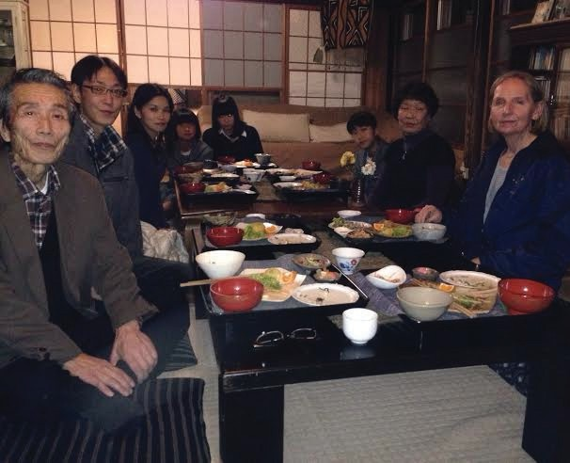
At the end of the day, the entire family met me at city hall. Kengo drove us to an organic restaurant that was a bit out of the city. We were driv- ing in the dark and got turned around a bit as the roads were not well lit or marked. Kengo’s parents met us there. The restaurant was a 400 year old building with paper & glass sliding doors. We sat on pillows on the floor at low tables and were served a wonderful vegetarian meal cooked by the lady who owns the restaurant. She made a wonderful bean and tofu salad, cabbage soup, rice along with tea and a slice of
her chocolate cake. Kengo’s father speaks English and played trans- later. I was able to get more information about Kengo and Mami. Both work for an Airline. Mami prepares menu’s and Kengo buys food from
retailers for the meals. After the dinner, the girls presented me with a set of chopsticks from the restaurant as a remembrance.

The following morning was my last time to spend at the Yoshida home. Mami prepared a traditional Japanese breakfast for me this time which was very good: maki rolls, rice, cooked broccoli, scrambled rolled egg with sauce and tea. I really appreciated having a breakfast that was the same as what their family ate. Mami once again drove me to city hall. I enjoyed staying with them. All the family members made me feel very comfortable even tho there was that inability to communicate very well. It made me sad that I did not know Japanese well enough to speak a little with them.

Host report: The Nagasaka Family

Debbie Wilhelm

The Nagasaka Family was my second host stay during my trip. I was first introduced to Yoki, Hana & Hagumu in the lobby of the Mecure Hotel the day after our arrival. They were very friendly and excited about my staying with them in a few days.

The evening after our band’s performance in Mobara I was met by Hana and Hagumu along with their grandmother, aunt and uncle. Yoki was working that evening. The family took Sharon Durtka (my fellow roomy) to Cooks Family Restaurant. It was a lot like a family restaurant in the US with a menu of Japanese and Italian food along with burgers & fries. Afterwards we drove to the Nagasaka home which was a two story home in a suburb. There were a variety of homes in this area along with garden plots. Sharon and I shared a bedroom on the second floor and slept on traditional bed mats on the floor.

In the morning Yoki made a wonderful breakfast with rice, broccoli, salad, fruit and tea. Both Hana and Hagumu were getting ready for school. Both were going to sports clubs that met before school. Hagumu loaded his back pack with books and his school uniform then hopped on his bike and pedaled to his school. Hana also had a backpack with books, homework and school uniform. I picked her backpack up and was surprised at how heavy it was for someone her size. But she thought nothing of it as she put on her coat and hefted it over her shoulder and onto her back to leave for school.

That evening Yoki came to get Sharon and I from City Hall after our day of per- forming. Along with Hana and Hagumu we went to a Sushi bar. This restaurant was unlike any sushi bar I’ve been to in the US. As we sat at our booth I noticed there was a conveyor that ran between the row of booths with choices of food on covered plates. As the dishes went past, dinners picked what they wanted and took it from the conveyor onto the table to eat. If you wanted something that was on the menu but not on the conveyor, there was a touch screen pad above the conveyor that you could scroll thru and by clicking the button next to the item order a specialty dish. A red light went on indicating your booth had a special order. Once the item was prepared it came to you on a second conveyor slightly above the regular one and stopped at your booth. You pushed the red button to the off position to indicate you had received your food. At each table was a slot for dirty dishes. When you were done eating the food
on a dish, you pushed the dish into the slot where it was taken by conveyor to the kitchen to be washed. For every 4 dishes put into the slot a chance to play a video game came up on the ordering screen. It was a short game and if you won, a small prize dropped down onto the table. Hagumu won a small key chain with a plastic cheese cake slice dangling from it. The whole eating ex- perience was a technical marvel. I’d never experienced anything like it before. After dinner we returned to the Nagasaka home where Hana and later Yoki came to my bedroom to talk with Sharon and I. We exchanged host gifts and afterwards Hana showed us pictures of her stay in the US from the previous year when her dance group came to Milwaukee to perform.
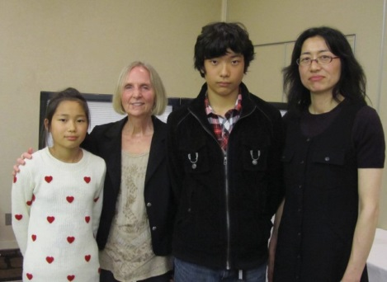
Hana, Debbie, Hagumu and Yoki

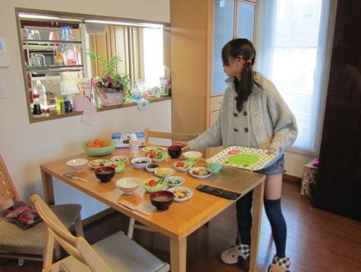
Breakfast with the Nagasakas.

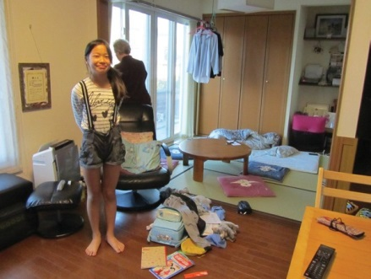
Hana getting ready for school

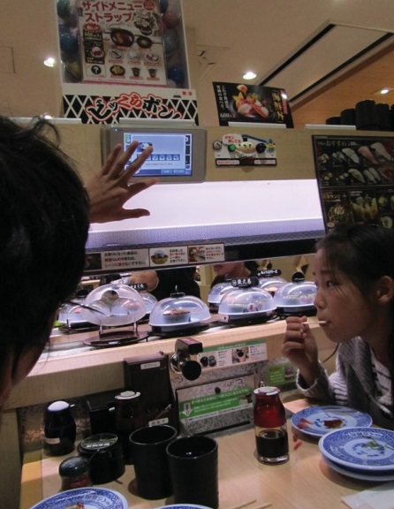
Dinner at the sushi bar

The next morning, being Saturday, Hagumu slept in so I had breakfast with Yoki and Hana. The TV was on and the news was showing Tokyo Disney opening for the Christmas season. Mickey & Minnie were in Christmas dress and the light parade was Christmas orientated. We briefly met Takeshi who was leaving for work – he started early in the mornings so this was the first time I was able to introduce myself. After breakfast Sharon and I had to pack up our suitcases and get ready to leave. My stay with the Nagasaka family was short but very nice. I had enjoyed staying with them – they were extremely nice hosts.

I had one last opportunity to meet with them and say goodbye at the delegation dinner that evening. I sat at a table with both the Nagasaka and Yoshida families. Hana was very sad to say goodbye at the end of the event and cried a little. I gave her a hug and thanked both her and Yoki for inviting me stay at their home to experience what it was like to live in a Japanese home and get to know them as friends. I had enjoyed my stay with them very much.

Conclusions for the 2014 Cultural Exchange Trip Report

Our traditional Celtic music band (The Garlic Mustard Pickers, Inc.) is extremely grate- ful for receiving the opportunity to be the Cultural Exchange contingent of the 2014 WCI delegation.

Two of our musicians are teachers. (One has taught at the “middle school” level for many years, and the other has worked with both high school and college students.) For these two musicians, the visits to the junior high and high schools were particularly rewarding. The cultures within Japanese schools offer a model from which American school adminis- trators could learn much.

One of our musicians is a Unitarian minister who has spent many years working for an Interfaith organization in Milwaukee. For this musician, the visits to the various reli- gious sites (both in Narita and in Tokyo) were very illuminating. But all of the musicians greatly appreciated having guides to show them around these sites. Miyazaki-san was able to bring us to both a Buddhist complex and a Shinto site. We were also very fortunate to have a volunteer guide accompany us in the Naritasan Shinsho-ji Temple, and to explain the significance of many of the things that we were seeing in this historic location. We were particularly lucky that the timing of our visit allowed us to attend a Goma ceremony in the Main Hall.

All of our musicians feel great gratitude toward the host families who so generously pro- vided us with a view of Japanese home life. This is something that most Americans visit- ing Japan could never experience. We feel very fortunate, and very honored, to have been welcomed as guests in these homes.

We are fortunate to have received a glimpse of the importance of calligraphy as one of the traditions of Japanese art. Likewise, we were very fortunate to have met the Tsubaki fam- ily and to have seen the artistry of the traditions of dance which they work to preserve.

It goes without saying that we are exceptionally fortunate to have had the opportunity to attend (and participate in) the celebrations of the 60th Anniversary Year for the City of Narita. We are extremely grateful to the members of Chiba-Wisconsin Association who recognized this opportunity, and who made it available for us.

Finally, the musicians of The Garlic Mustard Pickers offers sincere thanks to the members of the Chiba-Wisconsin Association, and in particular to the Secretary-General of that organization, Yasuko Aoki. The amount of work that she and her associates put into orga- nizing the logistics of our visit is, as judged by the results, truly impressive and amazing. We are deeply in Yasuko-san’s debt for her dedication and support, both before our visit, and during our visit. Arigatou gozaimasu, Yasuko-san!

